
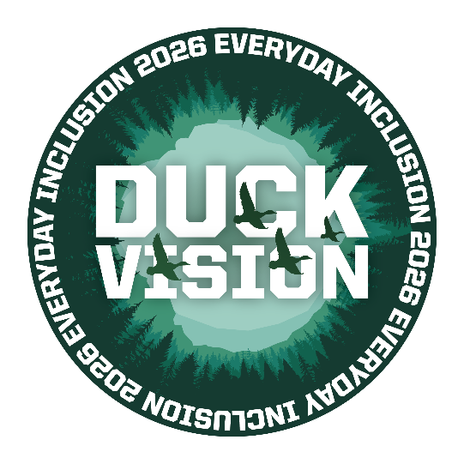
Everyday Inclusion 2026
Weekly Challenges

Week 4: January 26 - 30

- EXPLORE the science of self-control with UO Psychology professor Elliot
Berkman. Check out this 4-minute video on how to work with the brain

instead of against it to make a series of choices for lasting change.

- CHECK out the New York Times “10-Minute Challenge,” a monthly feature that challenges readers to view a piece of art for 10 minutes.

This month’s piece, “An Artist in Greenland,” is a striking, serene landscape with an incredible sense of scale. New York Times online is free for all UO employees: https://researchguides.uoregon.edu/nytimes

- LEARN how to embrace winter’s unique opportunities with health
psychologist Kari Leibowitz, author of the recent book How to Winter:
Harness Your Mindset to Thrive on Cold, Dark, or Difficult Days (22 mins)


- GET better at knowing what to say or do in situations that bother you. Thursday’s Rehearsals for Life workshop offers an online environment to build skills for confronting hard situations: https://uomytrack.pageuppeople.com/learning/4187
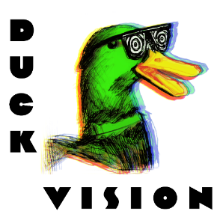
- TELL us what you liked and what could be improved for Everyday Inclusion in future years. Our goal is to provide opportunities to connect, engage, and grow with colleagues. We’d love to hear your thoughts.

(Duck Vision Image by Dave Fleming & AJ Locati, FASS Warehouse Services)

IN-PERSON AND VIRTUAL ACTIVITIES THIS WEEK
- Mon, Jan 26 & Tues, Jan 27, 1-1:45pm: Zebrafish laboratory tours (fully booked)
- Wed, Jan 28, 12:15-1pm: Gentle Yoga with Louise Hutson, Studio 283, Rec Center
- Thurs, Jan 29, 9-10:30am: ONLINE Rehearsals for Life workshop
- Fri, Jan 30, 11am-12pm: Bird tour with Rachel Glaeser and Emily Hamblen

**Register in MyTrack or contact Debbie Sharp at dsharp@uoregon.edu/541-346-3096 to sign up**
Everyday Inclusion 2026: https://vpfa.uoregon.edu/everyday-inclusion-2026-duck-vision
MyTrack: https://uomytrack.pageuppeople.com/learning/

