****[](https://vpfa.uoregon.edu/everyday-inclusion-2024-nourish-flourish)

**Weekly Challenges**

**Week 3: August 19-23**

[](https://oregonquarterly.uoregon.edu/uos-first-black-woman-grad-brought-lasting-change)

[](https://oregonquarterly.uoregon.edu/uos-first-black-woman-grad-brought-lasting-change)**1. CONNECT with UO history by reading about Nellie Franklin, the first Black woman to graduate from the university.**

**Scan the QR code at right 🡪**

1. **FIND out what people are doing to connect and support flourishing. What would you like your team to try?**

* **Information Services: Book Club**
* **Admin Services: "But first, coffee..."**
* **Human Resources: Craft and Chat**
* **SRS: Potlucks & the *infamous* snack table**

[](https://www.bu.edu/articles/2023/how-to-deal-with-workplace-loneliness/)

1. **LEARN about workplace loneliness and the importance of creating connections and actively including people.**

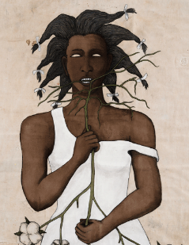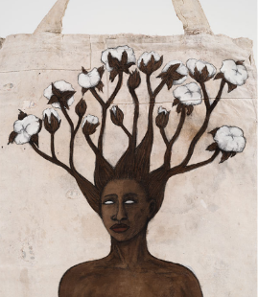

1. **TAKE a tour of current and past JSMA virtual exhibitions.**

<https://jsma.uoregon.edu/virtualtours>

[](https://native-land.ca/)

1. **EXPLORE the "sacredness of the land" around us with an interactive map and Territory Acknowledgement Guide created by Native Land Digital.** <https://native-land.ca/>

**IN-PERSON AND VIRTUAL ACTIVITIES THIS WEEK**

* **Mon, Aug 19, 12-1pm: Paint and Take tote bag activity in the Computing Center Room 105   
  No registration required—contact** dsharp@uoregon.edu **if you are not part of IS and want to join us)**
* **Tues, Aug 20, 3:30-5pm: In-person Book Club discussion of *Hijab Butch Blues* in Room 161 of the 1715 Franklin Bldg (register and receive a free book—join us even if you haven’t finished the book)**
* **Wed, Aug 21, 12-1pm: Intentionally Genderful with Kason Carte (Hybrid session in EMU and online)**
* **Thurs, Aug 22, 12-1pm: Nourishing Yoga with Louise Hutson (HR) (Studio 283 in the Rec Center)**
* **Fri, Aug 23, 11:15am-12:15pm: JSMA guided tour of two current exhibitions (meet in JSMA lobby)***\*\*Register in* [*MyTrack*](https://uomytrack.pageuppeople.com/learning/) *or contact Debbie Sharp at* [*dsharp@uoregon.edu*](mailto:dsharp@uoregon.edu)*/541-346-3096 to sign up\*\****Everyday Inclusion 2024**: <https://vpfa.uoregon.edu/everyday-inclusion-2024-nourish-flourish>