[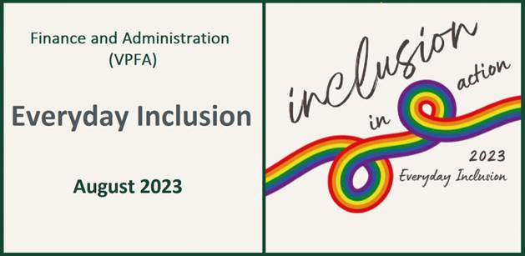](https://vpfa.uoregon.edu/everyday-inclusion-2023-inclusion-action)****

**Weekly Challenges Week 2: Aug 7-11**

1. **LEARN** about the positive actions that colleagues are trying out:

* I've added my pronouns to my email signature to be more inclusive of all pronouns/genders and to help normalize the process of offering pronouns and not assuming pronouns/gender.
* I talked to a colleague about a topic we hadn't discussed before: gender stereotypes at work.
* I spent time learning about body size discrimination in U.S. society after a friend shared their surprising and disheartening experiences.

Share your positive and inclusive actions at [**vpfadiversity@uoregon.edu**](mailto:vpfadiversity@uoregon.edu).

1. **SHARE** a children's story from your childhood with a co-worker or in your department.

[](https://storycorps.org/participate/great-questions/)

1. **CHOOSE** one of these great questions from Story Corps to have a conversation with colleagues, friends, or family: <https://storycorps.org/participate/great-questions/>
2. **TRY** giving micro-affirmations: in person, using email, by phone, or on Teams chat. When you have practiced micro-affirmations in private, start making a habit of acknowledging people in public—to affirm people aloud, giving them more credence.

<https://www.linkedin.com/pulse/six-micro-affirmations-help-support-others-work-sonali-d-silva/>

[](https://www.ted.com/talks/chimamanda_ngozi_adichie_we_should_all_be_feminists)

1. **DISCOVER** why Chimamanda Ngozi Adichie says *we should all be feminists*. If you enjoy the talk, sign up to receive her short 48-page book and discuss it on Aug 22. <https://www.ted.com/talks/chimamanda_ngozi_adichie_we_should_all_be_feminists>

**IN-PERSON AND VIRTUAL ACTIVITIES: This week and next**

* **Wed, Aug 9, 12-1pm**: Beginner Swing Dance (Lindy Hop), Lindsey Salfran (SRS), [Gerlinger Annex GRX352](https://map.uoregon.edu/4139b9abd)
* **Fri, Aug 11, 1-2pm**: Tour of two exhibits at the [Jordan Schnitzer Museum of Art](https://map.uoregon.edu/652aa811e)
* **Tues, Aug 15, 10:30-11:30am**, Psychological Safety at work, Deborah Butler (VPFA office), online
* **Wed, Aug 16, 10-11am**: Women in the History of the Campus Built Environment, Janell Cottam and Renee Benoit (CPFM Design and Construction), on-campus tour
* **Thurs, Aug 17, 2-3pm**: Inclusive Yoga - Balancing Action with Rest, Louise Hutson (HR), [Rec Center 283](https://map.uoregon.edu/d5c0207a8)
* **Fri, Aug 18, 9-11am**: [Grove Community Garden](https://map.uoregon.edu/1a961849c) drop-in volunteer session

*\*\*Register in MyTrack or contact Debbie Sharp at* [*dsharp@uoregon.edu*](mailto:dsharp@uoregon.edu)*/541-346-3096 to sign up\*\**

**Everyday Inclusion 2023**: <https://vpfa.uoregon.edu/everyday-inclusion-2023-inclusion-action>