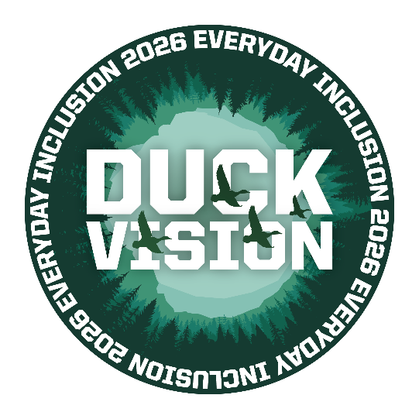


Weekly Challenges
Week 1: January 5-9

- REMEMBER the last time you received a handwritten thank you note? Take a minute to send one to a colleague for any kind act, big or small. Better yet, scan the QR code at right to request some Duck Vision note cards (complete with coloring supplies) to color and send to recognize folks who demonstrate Duck Vision in building positive work culture!

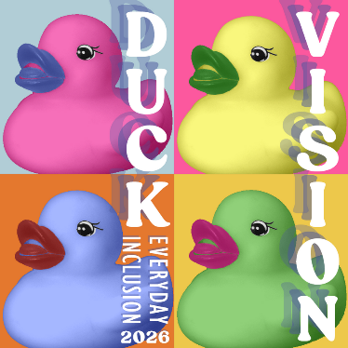
- CONSIDER how your hobbies and interests could impact your career by watching a 12-min video titled The Remarkable Impact of Hobbies on Career with Dr. Karen McFarlane Holman. Then sign up to join a casual virtual discussion or participate in a Teams channel chat throughout the month: https://uomytrack.pageuppeople.com/learning/4191

- EXPLORE the delightful and impressive array of sticker designs submitted for Everyday Inclusion 2026. Which image resonates with you? https://vpfa.uoregon.edu/everyday-inclusion-2026-duck-vision#stickers
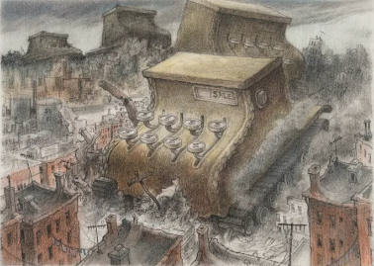
- LEARN about current exhibits during an in-person curator-led tour of the Jordan Schnitzer Museum of Art: https://uomytrack.pageuppeople.com/learning/4196
Image: Cheyenne Dickenson

- REGISTER for one activity this month, be it in person or virtual. We hope to see you there! https://vpfa.uoregon.edu/everyday-inclusion-2026-duck-vision

ACTIVITIES THIS WEEK
- Thurs, Jan 8, 12:30-1:30pm: Curator-led tour of current JSMA exhibits
- Fri, Jan 9, 1:30-2:30pm: Online discussion about The Remarkable Impact of Hobbies on Career (12min), with Deborah Butler (SVPFA office)

**Register in MyTrack or contact Debbie Sharp at dsharp@uoregon.edu/541-346-3096 to sign up**
Everyday Inclusion 2026: https://vpfa.uoregon.edu/everyday-inclusion-2026-duck-vision
MyTrack: https://uomytrack.pageuppeople.com/learning/

