[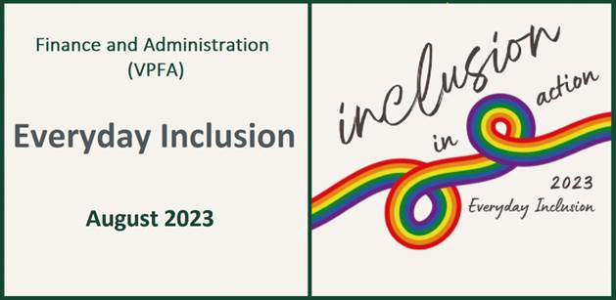](https://vpfa.uoregon.edu/everyday-inclusion-2023-inclusion-action)****

**Weekly Challenges Week 1: Aug 1-4**

1. **TRY** a new positive action. Maybe it’s something you've thought about for a while and maybe it’s something you just decided to try. You could support a minority-owned restaurant; reach out to a colleague; attend a different church; challenge a stereotype at work; acknowledge cultural holidays other than your own; or...
2. [](https://blogs.uoregon.edu/everydayinclusion2023threesentencestories/)**SHARE** your new action with us ([vpfadiversity@uoregon.edu](mailto:vpfadiversity@uoregon.edu)) and we will pass along the information to the portfolio to demonstrate what is possible.
3. **CREATE** a three-sentence story to inspire and entertain others. Check out <https://blogs.uoregon.edu/everydayinclusion2023threesentencestories/> or scan the QR code on the right to read story examples.

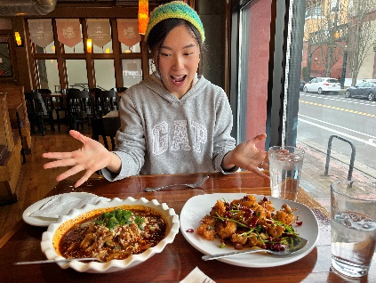

1. **LEARN** about colleagues across the portfolio by reading Employee Spotlights at <https://vpfa.uoregon.edu/vpfa-employee-spotlight>. Who did you read about? What was surprising about them?

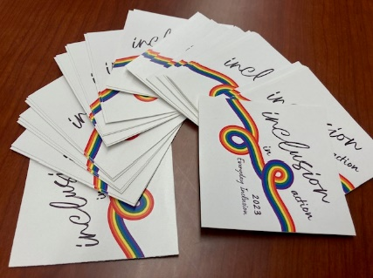

1. **PARTICIPATE** in any EI2023 activity and receive a peer-designed Everyday Inclusion sticker for your office, coffee mug, or water bottle. See: <https://vpfa.uoregon.edu/everyday-inclusion-2023-inclusion-action>

**IN-PERSON AND VIRTUAL ACTIVITIES: This week and next**

* **Thurs, Aug 3, 12-1pm**: Psychological Safety at Work, Deborah Butler (VPFA office), Allen Hall 140
* **Wed, Aug 9, 12-1pm**:Beginner Swing Dance (Lindy Hop) – No Partner Required, Lindsey Salfran (SRS), Gerlinger Annex GRX352
* **Fri, Aug 11, 1-2pm**: Guided tour of two exhibits at the Jordan Schnitzer Museum of Art

*\*\*Register in MyTrack or contact Debbie Sharp at* [*dsharp@uoregon.edu*](mailto:dsharp@uoregon.edu)*/541-346-3096 to sign up\*\**

**Everyday Inclusion 2023**: <https://vpfa.uoregon.edu/everyday-inclusion-2023-inclusion-action>