Everyday Inclusion Virtual Scavenger Hunt August 2021:
(Re) Connecting to People and Place - ANSWERS

These are the answers to the August 2021 virtual scavenger hunt created by the VPFA diversity committee.
- If you would like to download the Word version of the virtual scavenger hunt, it is available online: https://vpfa.uoregon.edu/everyday-inclusion-2021#EI21ScavengerHunt
- There is also a version you can complete online if you prefer to complete it that way (you will receive a copy of your submission).

- Which building on campus was the site of the first all-women's dormitory on campus?
Hendricks Hall
- Hendricks Hall was the first major collegiate building designed as a women's dormitory in Oregon.
- Hendricks holds significance as an example of Lawrence’s work (both as an individual building and as a part of its ensemble) as well as being the first all-women’s dormitory on campus.

- Which residence hall hosts the Comunidad de Latinx Scholars? Please answer using the name provided on the Spanish version of the UO map.
Hint: Check out Map Apps in the top right of the UO map.
Residencia Justice Bean (see https://mapdev.uoregon.edu/spanish)

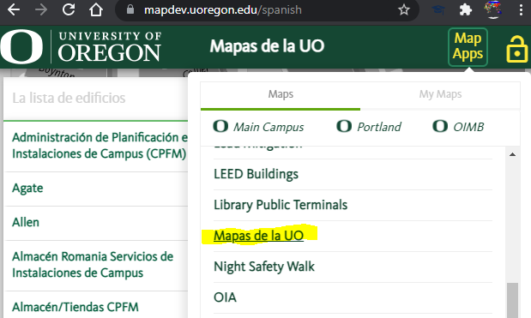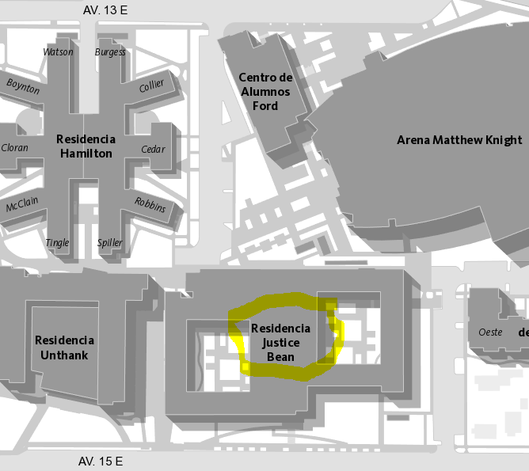

- In this video, what did Seattle-based author Ijeoma Oluo have to explain to her mother? Oluo is the author of several books, including So You Want to Talk about Race.

“Being a white woman who loves black people, who has even given birth to black people, is still very different from living as a black person and experiencing firsthand the full force of a white society every day of your life.”

- Currently housing the Department of East Asian Languages & Literatures, this former residence hall was home to the first UO African American students to live on campus and was the workplace for the first African American employee at UO. What is the name of the building?

Friendly Hall:
- Friendly Hall “housed the first students of color at the UO. According to the UO Special Archives “Unbound” blog, Bobby Robinson and Charles Williams, the first African American student athletes at the UO, moved into Friendly Hall as sophomores in the fall of 1927.”
- Another Eugene civil rights icon who made his mark in Friendly Hall was Wiley Griffon, the first African American employee at UO. He served as the janitor for Friendly Hall during the building’s years as a dormitory. Despite Oregon’s exclusion laws that forbade African Americans from entering or owning property in the state, Griffon found his way into Eugene as a street car driver. Once the streetcar service ended, he found his role at the university.

- Name one building on campus that has at least one baby-changing station AND at least one lactation room. Hint: Check out another one of those great UO Map Apps.
BONUS: Name all four buildings that have both types of facilities.

Family Friendly Resources map: https://map.uoregon.edu/s/family-friendly
The four buildings are: the EMU, the Knight Law Center, Lewis Integrative Science, and Oregon Hall.
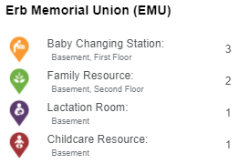
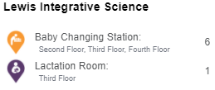
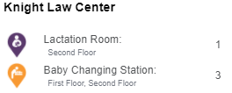
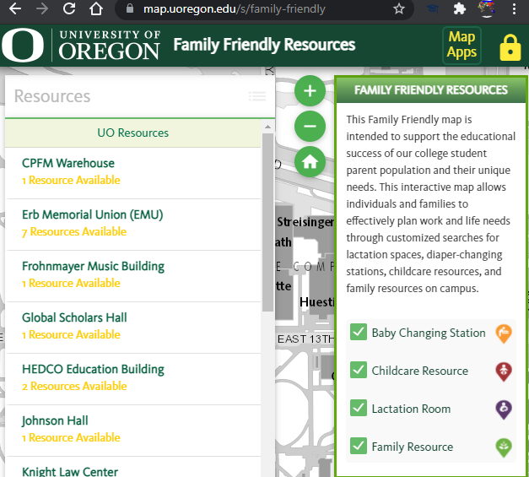

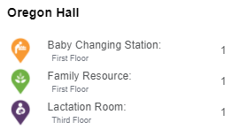
- Roughly how many all-gender restrooms are on the UO campus?
  - 0-50
  - 50-100
  - 100-150
  - 150-200

Use the All-Gender Restrooms UO Map App to find out: https://map.uoregon.edu/all-gender-restrooms
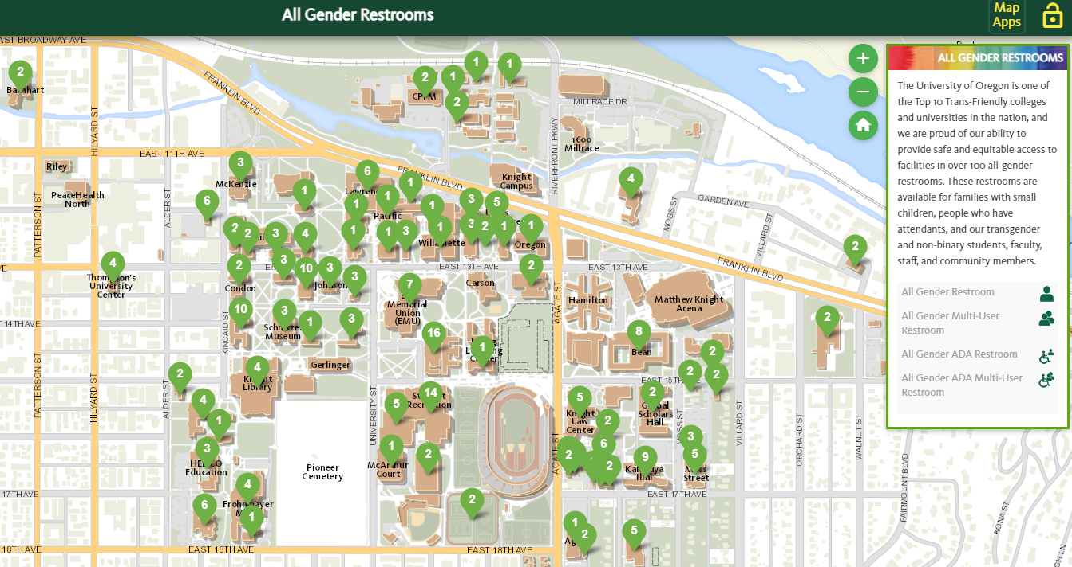

BONUS: Exactly how many all-gender restrooms are there and which building houses the most?

According to the experts at the UO Campus Geographic Information Services (GIS) office/Location Innovation Lab, there are 186 all-gender restrooms on campus. The map shows that Straub has the most with 16.

- Name one employee that has been spotlighted on the VPFA website.

VPFA employee spotlights are listed online here: https://vpfa.uoregon.edu/vpfa-employee-spotlight

BONUS: What interesting tidbit did you learn about this employee?
This will depend which of the 40+ employees you read about.

- This song, known as the Black National Anthem, is performed at the UO’s annual Martin Luther King, Jr. Day celebration hosted by the Division of Equity and Inclusion. What is the song’s proper name?
Lift every voice and sing
The 2021 MLK Jr. Commemoration took place online; listen to the Black National Anthem at the 5-minute mark: https://www.youtube.com/watch?v=yy9JlB5Zba0&t=5s

- Which UO building that was named and dedicated in 2019 to a well-known UO alumna and civil rights activist, features a large “front porch” incorporated into the building’s design as a representation of its cultural significance?

The Lyllye Reynolds-Parker Black Cultural Center: https://dos.uoregon.edu/bcc

BONUS: Who is the building’s namesake and what role did she play on campus?

The building was named after Lyllye Reynolds-Parker; she worked as an academic advisor in the Office of Multicultural Academic Success at the UO for 17 years, until she retired. https://dos.uoregon.edu/bcc

- According to Dr. Ibram X. Kendi in this video, what makes it hard for people to be anti-racist? Kendi is a National Book Award-winning and #1 New York Times bestselling author of eight books including How to Be an Anti-Racist and Stamped from the Beginning: The Definitive History of Racist Ideas in America.

“You have more people who are aware of racism and its horrible impact, but they are not willing necessarily to support the types of support of solutions that can eliminate racism. So their awareness has not transformed into action.”

- This building originally housed a 200-seat theater and a magnificent stained-glass skylight covering the entire center of the building. What is the name of the building?

Johnson Hall
“Originally the building housed, in addition to administrative functions, the Condon Geological Collection, as well as the 200-seat Guild Theater…Original interior decorative details included a magnificent skylight which covered the entire center of building and was made of stained glass by the Povey Brothers of Portland.” https://library.uoregon.edu/architecture/oregon/johnson

- A vital part of the university and our portfolio, the UO central power station uses many gallons of water each year for campus heating and cooling. Roughly how many gallons of water are used to cool campus buildings with chilled water annually?

About 29,730,000 gallons of chilled water are used to cool campus each year.
https://cpfm.uoregon.edu/utilities-energy/energy-management

BONUS: What is the cost of the water used to heat campus with steam each year?

Each year, the cost of water used to heat campus with steam is about $15,000.
https://cpfm.uoregon.edu/utilities-energy/energy-management

- Director of the Center for Black Studies and Assistant Professor in the Black Studies Department at Portland State University, Walidah Imarisha, created a program called, “Why aren’t there more black people in Oregon? A Hidden History.” Oregon has the dubious distinction of being the only state that entered the Union with a clause in its constitution forbidding what?
“Oregon was the only state that entered the Union with a clause in its constitution forbidding Black people to live here. That the punishment originally meted out for violating this exclusionary law was the “Lash Law”: public whipping every six months until the Black person left the state. That this ideology shaped Oregon's entire history and was reflected in the larger history of this nation.”
https://www.oregonhumanities.org/rll/magazine/skin-summer-2013/a-hidden-history/

- The UO has a wide range of residential communities for students to find connections outside classrooms and connect with students who have similar interests, identities, or values. Which residential community might a student choose if they are interested in acknowledging and celebrating people who are non-binary, two spirit, or genderqueer?
The Gender Equity Community is a “residential community for students who want to live with others who are committed to gender diversity, inclusion, and equity. The Gender Equity Community is intended for residents who acknowledge, experience, and celebrate the spectrum of genders inlcuding: agender, gender non-conforming, genderqueer, non-binary, trans*, two-spirit, etc.”
https://housing.uoregon.edu/communities/gender-equity-hall

- Custodial staff complete a phenomenal amount of work and make up a large proportion of the employees in our portfolio. How many custodial shifts are there within the VPFA portfolio? (If you don't know, check out the BONUS question for a place you might find the information)

The VPFA online org chart shows four custodial shifts: graveyard, weekend, day, and swing.
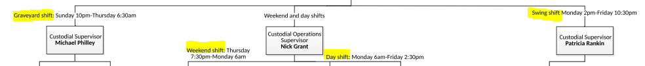
https://vpfa.uoregon.edu/finance-and-administration-portfolio-organizational-chart

BONUS: How many custodian positions are shown on the online VPFA org chart?
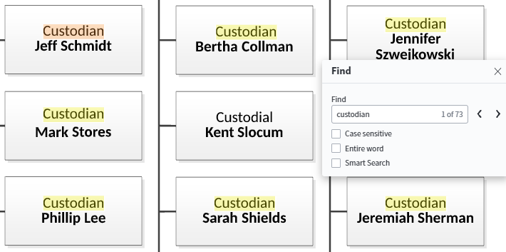
Using CTRL-F on the online VPFA org chart reveals a total of 73 custodians (this may vary depending on when you conduct the search).

- What is cultural humility, as the UO defines it?

“UO’s Working Definition of Cultural Humility:

Cultural humility is a practice of self-reflection on how one’s own background and the background of others, impacts teaching, learning, research, creative activity, engagement, leadership, etc.

It is committing to work individually and with others to end unjust power imbalances.

It leverages institutional accountability to redress oppression, discrimination and harm individually, interpersonally, institutionally and structurally.”
https://inclusion.uoregon.edu/cultural-humility

- Home to the Division of Equity and Inclusion, College of Arts and Sciences, and the Career Center, this five-story building has a different color palette on each level. What does the color on garden level (basement) represent?
Note: Serious Google search skills and perseverance required!

Tykeson Hall is home to DEI, CAS, and the Career Center: https://provost.uoregon.edu/tykeson-hall

If you Google “Tykeson Hall color palette” you will find out a few things:

- “Additional design aspects that help define the building’s unique character include a Pacific Northwest-inspired color palette and an emphasis on furnishings, fixtures and finishes that suggest warmth and welcome.
The color palette comprises a floor-by-floor color scheme (see below).
  - Garden Level — color scheme: Coast (marine blue and light gray reminiscent of the Oregon Coast)
  - First Floor — color scheme: Oak Prairie (warm greens and off-white that suggest the oak prairie of the Willamette Valley)
  - Second Floor — color scheme: Forest (deeper and cooler greens reminiscent of Oregon forests)
  - Third Floor — color scheme: High Desert (oranges, yellows, and reds that evoke the high desert and painted hills of Central and Eastern Oregon)
  - Fourth Floor — color scheme: Alpine (cool blue gray, light blue, and white, reminiscent of Oregon’s high peaks)
https://cas.uoregon.edu/2019/11/tykeson-hall-what-do-we-mean-by-designed-for-student-success/

- “Accentuating each floor on the interior is a geographic color palette evoking a distinct Oregon region: coast (garden/basement level), Willamette Valley (first floor), douglas-fir forest (second floor), high desert (third floor), and mountain alpine peak (fourth floor).”
https://www.office-52.com/image/DJC-Awards_2020-Article.pdf

- “To love a place is not enough. We must find ways to heal it.” This is a quote from the UO’s 2021-22 Common Reader. What is the name of the book?

The 2021-22 Common Reading is Braiding Sweetgrass.
https://fyp.uoregon.edu/common-reading-2021-2022-braiding-sweetgrass

BONUS: Of what nation is the author an enrolled member?
Author and botanist, Robin Wall Kimmerer is a member of the Citizen Potawatomi Nation.
https://fyp.uoregon.edu/common-reading-2021-2022-braiding-sweetgrass

- Human Resources is responsible for administering the university's Affirmative Action Program and making annual updates to the university's Affirmative Action Plans. According to the Affirmative Action section on the UO HR website, what groups are covered by the university's affirmative action plans?
“The University of Oregon maintains an Affirmative Action Program for women, minorities, veterans, and individuals with disabilities, providing annual updates on these efforts through its Affirmative Action Plan (AAP).”
https://hr.uoregon.edu/employee-labor-relations/affirmative-action/affirmative-action-plans

BONUS: Share one myth about affirmative action and summarize the corresponding reality.

“Myth: The pool of women and minorities in my field is so small that it is virtually impossible to effectively compete for the few who are available.
Reality: There are some fields which women and minorities have not entered in large numbers. There are no major disciplines, however, in which women and minorities have not earned terminal degrees. Effective outreach and recruitment are important in helping us reach and attract women and minority candidates, particularly in fields in which there is limited availability. Additional attention to innovative strategies, more personal outreach efforts, and the impact of unconscious biases may be required to compete for a limited number of qualified minority scholars.”
https://hr.uoregon.edu/employee-labor-relations/affirmative-action/affirmative-action-myths-and-realities

- About what does the Strides for Social Justice app educate users?

“The Strides for Social Justice app educate participants on the contributions, achievements and milestones of Black residents of Lane County, and also highlight the injustices many have faced.”
https://www.peacehealth.org/strides-for-social-justice

BONUS: Which UO employee is one of the Strides for Social Justice guides?
“Each route is guided by guides including Healthy Moves Executive Director Denise Thomas and Dr. Yvette Alex-Assensoh the Vice President for Equity and Inclusion at the University of Oregon.
https://www.klcc.org/post/strides-social-justice-app-offers-tour-black-history-eugene
OPTIONAL EXTRAS:
- Highlight something new you learned through this scavenger hunt.
- Please share any impressions you might have of this activity.

