rtsTo: Karl Scholz, President
From: Jamie Moffitt, Senior Vice President for Finance and Administration and CFO, TFAB Co-
Chair, and Angela Lauer Chong, Vice President for Student Life, TFAB Co-Chair
Date: February 13, 2026
Re: Recommendations of the FY2026 Tuition and Fee Advisory Board (TFAB)
Cc: Christopher P. Long, Provost and Senior Vice President

Executive Summary

The FY2026 Tuition and Fee Advisory Board (TFAB) is making the following recommendations related to tuition and mandatory fees:

- Incoming Cohort of New Undergraduate Students (2026 Tuition Cohort):

  - Residents: TFAB recommends that the guaranteed tuition rate for the 2026 Tuition Cohort, which will be locked for five years, be set at a rate that is 4.5% higher than that of the 2025 Tuition Cohort and that, in total, administratively controlled mandatory fees, which will also be locked for five years, be set at a rate that is 2.98% higher than that of the 2025 Tuition Cohort.

  - Nonresidents: TFAB recommends that the guaranteed tuition rate for the 2026 Tuition Cohort, which will be locked for five years, be set at a rate that is 3.0% higher than that of the 2025 Tuition Cohort and that, in total, administratively controlled mandatory fees, which will also be locked for five years, be set at a rate that is 2.98% higher than that of the 2025 Tuition Cohort.

- Graduate Students:

TFAB supports and includes for your consideration, all the proposed tuition changes for graduate programs outlined herein. Most proposals request increases ranging from 0.0% to 4.0% during the academic year. Further, TFAB recommends that in total, administratively controlled mandatory fees be set at a rate that is 2.99% higher than the current rate.

Overview

This memo provides detailed information about TFAB’s recommendations and is organized around the following topics:
- Tuition and Fee Advisory Board Process
- E&G Fund Budget and Financial Information
- FY2027 Budget Assumptions
- Tuition Scenarios Considered
- Proposed Tuition Increase for Incoming 2026 Tuition Cohort of Undergraduate Students
- Proposed Graduate Tuition Rates
- Proposed Fee Increases for Administratively Controlled Mandatory Fees
- Proposed College of Business Undergraduate Differential Tuition Rate
- Proposed Matriculation Fee Rate
- Proposed Clark Honors College Differential Tuition
- Other Costs of Education
- Tuition and Fee Policy Book
- Task Force Analyzing Tuition Plateau Framework

Tuition and Fee Advisory Board Process

The FY26 Tuition and Fee Advisory Board (TFAB) included five students. Student representatives were comprised of one graduate student and four undergraduate students, including two representatives from the Associated Students of the University of Oregon (ASUO). The 22-member group also included faculty members, a dean, vice presidents, vice provosts, a divisional dean, an associate dean, and administrative staff engaged in activities of budgeting, business affairs, institutional research, the registrar’s office, design and construction, student life, and financial aid. A list of TFAB members is included at the end of this memo (Appendix A).

TFAB met ten times between October 2025 and early February 2026. All meetings were open to the public and were held in person on campus, with the option for virtual participation upon request. Other students, faculty, and staff participated in TFAB meetings as guests during the fall and winter terms. A full list of guests is included at the end of this memo (Appendix B).

Fall 2025 meetings focused on the president’s charge to the group and guiding principles as well as critical information and training necessary for TFAB to make informed recommendations to the university president. These topics included:
- historical and comparative data, including undergraduate tuition and mandatory fee history, undergraduate enrollment, and the history of state appropriations to the university;
- the budget of the university, covering major revenue streams and cost drivers, funding challenges, enrollment challenges, and the impact of recent rounds of cost reductions at the university;
- information on the mechanisms by which moneys are appropriated by the Legislative Assembly to the Higher Education Coordinating Commission (HECC) for allocation to public universities, and its relationship to tuition;
- the guaranteed tuition program;
- projected cost drivers;
- long-term budget projections;
- the cost management plan; and
- an overview of financial aid at the university, including need-based and merit-based financial aid; state and federal student aid in FY25; changes to the FAFSA (Free Application for Federal Student Aid) in 2025 and federal loan programs in 2026; and the university’s increasing investment in scholarships.
Throughout fall term, TFAB meetings were designed to provide members training in order to increase their understanding of institutional finances and create a foundation from which they could make informed recommendations to the president. TFAB members who were unable to attend scheduled meetings in the fall were offered make-up sessions with staff. This ensured that all TFAB members had access to the necessary background information and training to inform their evaluation of tuition and fee proposals received during winter term.

Winter 2026 meetings included information on updated FY27 cost drivers, and historical information showing year-over-year tuition increases for Oregon residents and nonresidents at the UO between 2021 and 2026 compared to the average increases over the same period for public universities within the Association of American Universities (AAU). Also, during winter term, TFAB received proposals for changes to administratively controlled mandatory fee rates, which include the building fee, health service fee, recreation center fee, student union fee, and technology fee. TFAB received and discussed proposals about proposed FY27 housing rates, graduate tuition, and course fees, and discussed a proposal by the Lundquist College of Business to increase the differential tuition fee on undergraduate business courses beginning in the upcoming academic year for the entering cohort of undergraduate students. The group invited speakers from Government and Community Relations (GCR) and Student Services and Enrollment Management (SSEM) to share insights into the current state and federal landscape, the current context for recruitment in higher education nationally, and potential impact specifically related to recruitment at the UO. The group also reviewed the updated tuition and fee policy book for the 2026-27 academic year and 2027 summer session and discussed whether the president should convene a task force to research and analyze the issue of reestablishment of a tuition plateau for undergraduate students at the University of Oregon. TFAB spent time discussing trends, forecasts, and the potential impacts different tuition rates could have on FY27 student recruitment and the enrollment of domestic, international, and transfer students. The group discussed many different potential tuition rates for the new, incoming cohort of undergraduate students, considering various assumptions around enrollment levels, state appropriation, and changes in compensation and costs of supplies and services (S&S).

TFAB members expressed concern about how the university will meet the rising operational costs of providing high-quality education and student services, while also recognizing the very real financial difficulties faced by students and families in Oregon and nationwide in affording the costs of higher education.

In addition to the ten regular TFAB meetings outlined above, TFAB and ASUO co-hosted an in-person student forum on the tuition-setting process during the second week of winter term. The event included:
- Engagement questions designed by ASUO about university finances and tuition setting;
- A presentation on UO’s budget structure, funding sources, anticipated FY27 cost drivers, and the guaranteed tuition program.
- Information on advocacy opportunities for students to engage with state policymakers (for increased higher education funding); and
- Small-group discussions facilitated by TFAB members and senior university leaders.

Student feedback was collected and shared with TFAB in the meeting that followed the tuition forum. A summary of the feedback is included in Appendix C. A second student forum, which you will host, is scheduled for Thursday, February 19.

Information about TFAB and tuition was posted online (https://vpfa.uoregon.edu/tuition). This information was updated regularly during the 2025-26 TFAB process to ensure that members of the university community interested in the process had ready access to the materials being discussed by the advisory board. The TFAB meeting schedule, including meeting times and locations, was posted at the beginning of each term, and meeting agendas were posted prior to each meeting. Documents and data considered by TFAB were posted online following each meeting, as were summaries of the discussions conducted at each TFAB session. Finally, the tuition pages online provided updated information such as a description of the tuition-setting process, historical tuition and fees information, state appropriations, cost drivers, the university’s budget, and budget and tuition information for comparator public universities in Oregon, the Big Ten, and the AAU. Documents from the 2025-26 TFAB meetings will remain online as a record of the annual process.

E&G Fund Budget and Financial Information

In FY25, the UO had a balanced E&G fund budget, meaning that the university collected enough revenue to cover expenses. As a part of its fiduciary duty, the Board of Trustees regularly reviews long-term projections for the Education and General (E&G) Fund. At the Board’s June 2025 meeting the long-term projections indicated a structural deficit of $25 million to $30 million dollars in recurring annual losses. This forecast was confirmed at the September 2025 meeting with updated enrollment and cost information. By this time, the anticipated structural deficit had grown to slightly over $30 million during the forecast period FY26 to FY30.

This structural deficit was due to the fact that costs, largely driven by compensation-related increases, were projected to grow at a much faster rate (6.1%) than revenue (2.4%). Challenges related to recruiting nonresident domestic students have resulted in each of the last two entering cohorts (fall 2024 and fall 2025) being smaller than was anticipated given the significant investments that were made in student scholarships. Prior to any budget actions, the annual E&G Fund deficit for FY26 was projected to be $21.6 million. This figure would grow to $39.2 million in FY27 due to the graduation of the very large cohort of nonresident students who enrolled in fall 2022 and were replaced with much smaller cohorts in subsequent years, as well as PERs / blended OPE impacts.

For this reason, the UO implemented difficult budget cuts over the summer and fall of 2025 that eliminated $29.2 million of recurring expenses, largely through personnel reductions. 176 positions were impacted across the institution, which were a combination of 117 filled and 59 vacant positions. After the budget reductions, the forecasted E&G Fund deficit was reduced to $4.0 million (FY2026) and $8.2 million (FY27). The long-term projections showed this deficit closing to $1.7 million - $3.0 million a few years further out.

The E&G budget covers the majority of the operations of the academic and non-auxiliary administrative functions of the university.

During fall and winter meetings, TFAB discussed the major anticipated cost drivers in the E&G Fund for FY27, which are already captured in the figures cited above. These increases in costs are necessary to keep E&G-funded operations running at the current service level. As the university is currently in bargaining with two labor groups, SEIU and GTFF, not all increases in compensation-related expenses (Salary and Other Payroll Expenses) for FY27 are known. Furthermore, tuition decisions made this year for the entering cohort of undergraduate students will affect revenue through FY31 due to the guaranteed tuition program; during this time period, new contracts will be implemented with all of the institution’s labor unions. The projected compensation-related cost increases in the cost driver analysis are based on current contracts (e.g., faculty), announced increases for OAs and assumptions of 3% annual increases for those groups without ratified contracts. To help TFAB understand how changes in compensation could affect the budget, TFAB members had the ability to run tuition scenarios that included increases in general compensation and services and supplies (S&S) costs for the E&G fund.

For FY27, the following major cost increases are projected in the Education and General (E&G) fund:

Cost Driver | Estimated FY27 Cost Increase
Faculty, Staff, and Graduate Employee Salaries and OPE (Other Payroll Expenses) | $22.2 million
Blended OPE (reduction of one-time carry forward funds) | $6.4 million
Medical Costs (state-mandated health insurance) | $2.4 million
Institutional Expenses (increases related to utilities, insurance, debt for academic buildings, assessments and leases) | $1.8 million
Strategic Investments (allocated during the strategic investment process) | $1.0 million
Total Projected Cost Increases | $33.8 million

The $33.8 million in projected cost driver increases for FY27 represents a 4.8% increase over the FY26 E&G fund budget.

We are projecting $11.6 million of the $29.2 million in recurring savings from the implemented budget cuts to be realized in FY27 which will reduce expenses and offset some of the impact of these cost drivers. This will bring the total year-over-year increase in costs in the E&G Fund, after budget reductions, down to $22.2 million, which represents a total increase of expenses in the E&G Fund of 3.2%.

Total Projected Cost Driver Increases: $33.8 million
Budget Cut Savings realized in FY27: -$11.6 million
Net Projected Increase in FY27 Expenses: $22.2 million

FY2027 Budget Assumptions
Considering the economic uncertainty facing the university, several factors could impact next year’s Education and General Fund budget. The following budget assumptions were considered by TFAB when discussing scenarios and recommendations around tuition and fees for the coming year:

- Forecast FY26 E&G budget gap (Dec Q1 forecast) $ 2.0 million
- Projected FY27 cost drivers $ 33.8 million
- FY26 budget reductions $ 11.6 million
- Expected Increase to State Appropriation $ 6.0 million
- Projected Increases to Graduate Tuition $ 2.5 million
- Projected Increase to Summer Tuition $ 0.6 million

Additional areas discussed by TFAB:
- Unpredictability of student enrollment
- Uncertainty around state and federal support for higher education
- Challenges for the university budget
- The guaranteed tuition program
- Impact of federal changes to financial aid
- The longer-term financial picture beyond FY27

Enrollment Uncertainty

TFAB discussed how the university is currently facing a very competitive enrollment environment. Universities across the country are facing a myriad of budget challenges including the actual or potential loss of federal research funding, state appropriation cuts, reductions in federal financial aid, and challenges to international student recruiting and are therefore looking to expand nonresident domestic class sizes to increase their tuition revenue. As a result, the UO recruitment landscape, particularly for nonresident students, is even more competitive than in previous years. The university is trying new recruitment strategies, but the national and international student recruitment landscape is a challenging one. TFAB members discussed the UO’s current enrollment capacity in terms of academic and residential services, the importance of continuing to provide a high-quality education to resident and nonresident students, the connections between the admissions and yield rates, and their impact on perceived competitiveness. Members discussed the value of transfer students, the viability of international campuses, how changes to federal loan rules might impact graduate enrollment, and recommendations for improving collaboration between universities in Oregon to improve efficiencies.

Enrollment uncertainty, particularly around nonresident students, leads to great uncertainty for the university’s budget. There continue to be headwinds outside the control of the university (e.g., recent federal actions, demographic changes, etc.). These considerations greatly impacted discussions about tuition rates for the incoming 2026 cohort. Currently, nonresident tuition revenue significantly subsidizes the funds received, both from the state and students, for the education of resident students. TFAB continues to be cautious about the magnitude of recommended rate increases for nonresident students, aiming to balance the negative impact that price increases can have on attracting out-of-state students to the university with the need for incremental revenue to cover the cost drivers discussed in the previous section.

TFAB considered more than 70 different FY27 budget scenarios, with various assumptions about enrollment levels for different groups of undergraduate students, changes in compensation and S&S costs, and state appropriations, to better understand how different enrollment assumptions and potential tuition rates would affect the university’s financial position. A full list of scenarios discussed is included in Appendix D. It was noted that given the large graduating nonresident class (that entered in the fall of 2022) and expected PERS/blended OPE changes, FY27 is going to be a difficult budget year. The long-term projections discussed with the Board in September of 2025 estimated an $8 million FY27 deficit. Discussion of various tuition rates and enrollment assumptions confirmed that there were no realistic revenue scenarios that eliminated this deficit.

State Appropriations

Decades of state underinvestment have left Oregon’s public universities among the lowest-funded in the nation on a per-student basis. As a state, Oregon currently ranks 46th in state funding per student for four-year universities. Neighboring states like Washington and California invest significantly more in higher education, allowing their public universities to keep tuition rates lower and maintain greater access for students. Within Oregon, the UO receives the lowest level of state appropriations per resident student out of all public universities, increasing its reliance on tuition to cover operating costs.

TFAB spent time comparing state appropriations for the University of Oregon with state appropriations for other public universities within the AAU and Big Ten. The group also discussed changes in state appropriations to the UO between FY1990 and FY2025, noting that persistent state underfunding places greater financial burdens on Oregonian students and families because of increased reliance on tuition to maintain university operations. The group discussed the anticipated impact of federal cuts on the state of Oregon’s budget and the potential for that to negatively impact state appropriation levels for higher education. The group also discussed the state’s increasing investment in the Oregon Opportunity Grant over the past few years and emphasized the need for greater state understanding of the positive impact that UO has had as a driver of economic development in the state.

The legislatively approved budget (LAB) for the 2025-27 Public University Support Fund (PUSF) was $1,068.8 million. This funding supports all seven public universities in Oregon for two years. While this figure represents a small increase from the last budget cycle (2.8% increase between FY25 and FY26), it falls far short of the minimum state funding needed to maintain the state’s current very low share of the University of Oregon’s Education & General (E&G) fund budget.

The Higher Education Coordinating Commission (HECC) has cautioned that funding at such a low level has serious implications for Oregon’s public universities, including tuition increases, reductions in services, and threats to institutional stability. There has been discussion that the state’s revenue forecast, combined with federal tax and funding actions, could lead to mid-cycle budget cuts for Oregon’s public universities. While the February 2026 state budget forecast was positive by over two hundred million dollars, there is still concern that the state may implement mid-biennium budget cuts to better position itself to handle the impact of recent federal policy changes.

Budget Challenges

Budget reduction actions taken in calendar year 2025 have been difficult for the university community, with ongoing challenges given the magnitude of actions necessary. Unfortunately, reductions in personnel were necessary to deal with the projected structural deficit given that compensation costs represent almost 80% of the E&G fund budget. The costs of compensation and OPE as well as services and supplies (S&S) continue to rise, which in the face of uncertain enrollment and a challenging national landscape for higher education, make for a particularly uncertain budget situation.

The group spent time in several meetings discussing the background of the long-term projection process, long-term projection data, and the 2025-26 budget reductions. TFAB members discussed factors such as inflation, budget modeling, labor contracts, operational expense elements, and how the UO fund balance (weeks of operating expense) compares to that of other universities. Of particular importance, TFAB noted that UO’s largest class of nonresident students will be graduating this June and has been replaced with a smaller cohort. This, along with benefit cost increases related to retirement and health costs, is expected to have a significant impact on the FY2027 E&G fund budget.

Guaranteed Tuition

TFAB members discussed the benefits of the guaranteed tuition program at various points during fall and winter terms, and the stability that it provides to students and families to know that their tuition and administratively controlled fee rates are locked for five years. The group noted that several other comparator universities also have guaranteed tuition programs in place, reducing the comparative advantage for the UO. Having said that, the group acknowledged the value of the program in offering students and families predictability in the cost of tuition and fees. Of particular value is how the Oregon Guarantee protects the value of scholarships, allowing students and families to plan for the total cost of education and protects them from the impact of rising tuition and costs.

It was noted that due to the guaranteed tuition rate structure, the UO’s first-year tuition rate is higher than it would be otherwise, providing the appearance of a higher initial “sticker price” for students comparing the UO first-year price with the first-year price of universities that do not have tuition guarantee programs. If prospective students and families do not fully understand the financial benefit of the tuition guarantee—and the protection from inflation over a five-year period—the university may appear more expensive than it really is compared to other schools.

Financial Aid

TFAB members spent time discussing the serious challenges that high tuition rates pose for resident and nonresident students. The group discussed UO tuition and fees compared to public universities in the AAU and Big Ten, trying to balance the need to cover growing institutional costs while also acknowledging the increasing financial burden placed on students and their families. TFAB spent time discussing the current financial aid landscape for current and prospective UO students, noting that there are challenges on the horizon federally, with significant changes taking effect this year for Parent PLUS loans and Grad PLUS loans. The group discussed how much financial aid is disbursed each year, the percentage of first-year students receiving aid, the average debt of borrowers, how the Cost of Attendance (COA) compares to the COA of other Oregon universities, and whether the university has a higher proportion of low-income students than other universities.

The UO invests considerable resources in need-based financial aid to increase affordability where possible, including the PathwayOregon program, which provides robust financial and advising support to eligible low-income Oregonians. The group discussed how PathwayOregon works to support students, noting that students who do not qualify for the program or other financial aid resources face significant challenges. TFAB noted that persistent underfunding of four-year universities by the state is dramatically restricting access to higher education and hinders completion rates for low- and middle-income students. The group also discussed how changes to the Parent PLUS and graduate student loan programs could dramatically affect enrollment.

Tuition Scenarios Considered

With these issues as context for their discussions, TFAB reviewed a broad range of tuition rate scenarios for new undergraduate students entering the university in the 2026 Tuition Cohort. Under the guaranteed tuition program, tuition rates will be fixed for five years for the incoming 2026 cohort.

In scenario discussions, TFAB assumed the following operational cost factors as constants:
- FY26 projected E&G fund budget gap: $2.0 million
- Impact of Budget Cuts on FY27 Expenses: $11.6 million
- FY27 projected cost drivers: $33.8 million
- Incremental summer tuition: $600,000
- Incremental graduate tuition: $2.5 million
- Incremental remissions: 10% plus additional funds to continue to roll out the increased scholarship program from fall 2024.

Using the above cost factors, TFAB explored differing scenarios for enrollment of first-year and transfer resident and nonresident students, the impact of increased compensation and services and supplies (S&S) costs, new state appropriations, and tuition rate increases for undergraduate resident and nonresident students. TFAB members noted that, in addition to the assumption about state appropriation, changes to assumptions about nonresident enrollment and nonresident tuition rates have the largest impact on the university’s financial position.

TFAB members received the tuition calculator after the first meeting of winter term, which ensured they were able to spend four weeks exploring different tuition scenarios individually, in addition to the 70 scenarios discussed as a group. As a group, TFAB considered the scenarios listed in Appendix D.

Proposed Tuition Increase for Incoming 2026 Tuition Cohort of Undergraduate Students

TFAB recommends the following guaranteed tuition rates for the 2026 Tuition Cohort of undergraduate students:

- Resident tuition: TFAB recommends the guaranteed resident rate for the 2026 Tuition Cohort be set at $322.93 per student credit hour (4.5% above the 2025 Tuition Cohort rate). This tuition rate is guaranteed for five years and will not increase during that time. Typical annual full-time tuition (45 credit hours per year) for new resident undergraduates will be locked at $14,531.85 per academic year.

- Nonresident tuition: TFAB recommends the guaranteed nonresident rate for the 2026 Tuition Cohort be set at $989.40 per student credit hour (3.0% above the 2025 Tuition Cohort rate). This tuition rate is guaranteed for five years and will not increase during that time. Typical annual full-time tuition (45 credit hours per year) for new nonresident undergraduates will be $44,523.00 per academic year.

TFAB members took a great deal of time coming to these proposed rate increases, expressing concern about maintaining competitive tuition rates for recruiting, discussing the financial impacts on prospective resident and nonresident students, and acknowledging the need to cover the increasing costs impacting the E&G Fund budget. The group noted that increasing competition around nonresident enrollment nationally, along with increasing operational costs and the unlikelihood of a significant increase in state funding, means that the university is forecasting budget deficits for the next few years, in line with what was discussed with the Board of Trustees in September. The group considered projected cost drivers, increasing costs of higher education, university-funded scholarship programs, pressures on students and families, and how the overall cost of attendance at the UO affects resident and nonresident enrollment.

Proposed Graduate Tuition Rates

Deans for each school and college provided detailed recommendations for graduate tuition rates for the FY27 academic year and summer term, and for the off-cycle programs beginning in summer 2026. These recommendations for graduate tuition were based on prevailing market rates, overall cost drivers, and pricing considerations specific to their programs, industry trends, and departmental budget considerations. Each college also provided narrative information on the proposed tuition rate adjustment as well as an overview of student engagement. Overviews of the proposed graduate tuition rates for programs in the academic year 2026-27, summer 2027, and off-cycle summer 2026 programs were reviewed and discussed by TFAB during winter term.

There are over 80 separate tuition rates for graduate programs across the University of Oregon. The majority of proposed graduate tuition rate increases for the FY27 academic year range from no increase to 4.0 percent. Summaries of the proposed graduate program tuition rates for the FY27 academic year, summer 2027, and off-cycle summer 2026 term programs are included at the end of this memo (Appendix E, Appendix F, Appendix G). Footnotes on this summary describe changes in tuition structures being proposed by the various programs.

There were two schools/colleges that were not proposing any tuition rate increases for their programs despite rising cost drivers, College of Design and School of Law. This was due to competitive pressures.

College of Design

The College of Design is proposing not to increase graduate tuition rates for the next academic year. The college is currently engaged in a comprehensive review of existing graduate tuition structures, which aims to ensure pricing is in line with program value. Many years ago, the College increased tuition rates significantly and there has been concern that this negatively impacted enrollment. As the market analysis is not yet complete and the college is still looking at pricing models, competitive demand, and long-term program sustainability, the college has decided not to increase graduate tuition rates for the next academic year.

School of Law

The Law School is also not proposing a rate increase for its programs. For many years the JD tuition rate increased at a faster rate than other graduate programs. TFAB’s understanding is that this recommendation is based on market dynamics.

College of Business

The College of Business is proposing a 6.09% increase in tuition for the summer 2027 Sports Product Management graduate program. The college is increasing the summer rate to match the rate of the program during the regular academic year ($17,387.00 per term).

TFAB recommends that all proposed graduate tuition and fee recommendations be adopted.

Proposed Fee Increases for Administratively Controlled Mandatory Fees

TFAB reviewed proposals for FY27 administratively controlled mandatory fees. This includes all mandatory fees except the Incidental Fee, which is reviewed through a separate ASUO process. Administratively controlled mandatory fees are part of the guaranteed tuition program, therefore the rates set for the incoming 2026 Tuition Cohort of undergraduate students will be locked for five years. Administratively controlled mandatory fee rates paid by current first-, second-, third-, and fourth-year undergraduate students within the guarantee program are locked for five years and will not change.

TFAB considered FY27 rates for the following groups of students:
- incoming cohort of undergraduate students (2026 Tuition Cohort), and
- graduate students.

Each unit proposing increases to administratively controlled mandatory fees presented their proposals to TFAB during meetings in winter term. TFAB members received materials about the increases ahead of each meeting, giving them the opportunity to consider questions and concerns ahead of presentations about proposed fee increases. During the meetings, TFAB members had opportunities to ask questions and understand the rationale behind each proposed fee increase. Members were generally supportive of the proposed fee increases, realizing that the same cost drivers faced by the university in the E&G Fund are also being faced by the units that are funded by the administratively controlled mandatory fees.

TFAB members also recognized the importance of continuing to support services for students, whether the investments involved updating classroom technology and mission-critical software or supporting the staff, student labor, and general operating costs at the student union, recreation center, and university health services. The group recognized the collaborative efforts being made across campus to ensure overall mandatory fees increase as little as possible each year, despite increasing cost driver pressures across the university. The fees for the new, incoming undergraduate students (2026 Tuition Cohort) will be locked for five years under the guaranteed tuition program.

Below is a brief summary of key issues noted about each proposal.

Building Fee: No increase proposed.

Health Service Fee: The proposed increase varies by student group.

- Incoming undergraduate cohort: 3.42% ($9.25 per term) – this rate will be locked for five years.
- Graduate students: 3.28% ($8.75 per term)

The proposed increase to the Health Service Fee for the coming year will assist with covering the same cost drivers faced by the rest of the university, most notably staff salaries and benefits, an increase in student labor costs, and increases in general operating costs such as supplies, utilities, and overhead.

Recreation Center Fee: The proposed increase varies by student group.

- Incoming undergraduate cohort: 2.75% ($4.75 per term) – this rate will be locked for five years.
- Graduate students: 2.89% ($4.50 per term)

The proposed increase to the Recreation Center fee for FY27 will cover the same cost drivers faced by University Health Services and the rest of the university, including staff salaries and benefits, student labor, general operating costs (services and supplies), utilities, and overhead expenses.

Student Union Fee: The proposed increase varies by student group.

- Incoming undergraduate cohort: 2.70% ($6.50 per term) – this rate will be locked for five years.
- Graduate students: 3.29% ($7.50 per term)

As with the Recreation Center and University Health Services, the Erb Memorial Union is facing the same cost drivers, which the Student Union Fee will help cover. These comprise staff salary and benefit costs, student labor, general operating costs (services and supplies), overhead expenses, and bond payments.

Technology Fee: The proposed increase varies by student group.

- Incoming undergraduate cohort: 4.85% ($3.25 per term) – this rate will be locked for five years.
- Graduate students: 3.03% ($2.00 per term)

The proposed technology fee increase is in response to significant increases in the cost of software and hardware technology over the past few years, which can be attributed to supply chain issues, tariffs, and how artificial intelligence is impacting costs, particularly in hardware.

Administratively Controlled Mandatory Fee Summary: The total proposed increase varies by student group.

- Incoming undergraduate cohort: 2.98% ($23.75 per term) – this rate will be locked for five years.
- Graduate students: 2.99% ($22.75 per term)
For the incoming 2026 undergraduate tuition cohort, the fee rate will be locked for five years as part of the guaranteed tuition program. Current first-, second-, third-, and fourth-year students will see no increase in administratively controlled mandatory fees.

The table below reflects a summary of proposed rates for administratively controlled mandatory fees for FY27 outlined above. Rates listed are per student per term.
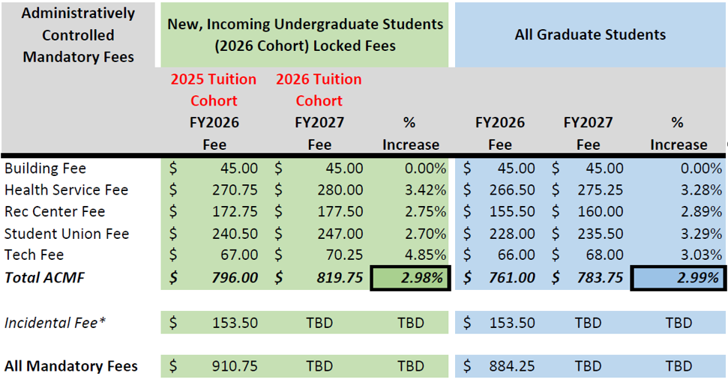

Incidental Fee: The Incidental Fee (I-Fee) proposal is developed by the ASUO and does not run through the TFAB review process. The ASUO recommendation will be sent to you separately for your review.

Proposed College of Business Undergraduate Differential Tuition Rate

The Lundquist College of Business is proposing a further increase to the undergraduate differential tuition at the college. The current differential tuition was raised last year from $20 per student credit hour to $30 per credit, effective with the 2025 Tuition Cohort. Prior to last year, the undergraduate differential at the college had been $20 per credit hour since its inception in FY19.

Beginning with the 2026 Tuition Cohort, the Lundquist College of Business is proposing to increase the differential tuition fee on undergraduate business courses from $30/credit hour to $50/credit hour. Differential tuition is part of the guaranteed tuition program so the higher rate would only apply to the entering cohort of students and will not affect current students. The rationale for the proposed higher rate includes increased costs to fund high-quality faculty and maintain student services related to career services at levels that are expected by students in a business school and are competitive with comparator schools. The increase in differential tuition was proposed following extensive analysis of differential tuition rates at comparator schools and input from the Dean’s Council for Inter-Club Coordination. Students consulted supported the idea of high-quality faculty and student services and appreciated the college’s plans to commit some of the differential tuition revenue to support PathwayOregon fee remissions for low-income students. The proposed differential tuition rate was in line with rates at other competitive universities in the state and across the country. It was noted in TFAB that additional analysis about necessary fee remission levels should be conducted.

Below is a table showing differential tuition comparators for Oregon and other AAU public universities with low levels of state support. The full proposal from the Lundquist College of Business is included in Appendix H. Because different universities have various differential tuition rate structures or operate on semesters, the table below provides data on their anticipated total cost of differential tuition for students during their course of study. This provides an “apples-to-apples” comparison.

Table: Differential Tuition Comparators
The Ten AAU Publics with the Lowest Level of State Support
 | Total Additional Costs for Business Major¹ |  | State Appropriations Per Student FTE (FY2022)²
 | Resident | Non-Resident
University of Colorado - Boulder | $24,288 | $15,952 | $3,163
University of Oregon (Proposed) | $4,400 | $4,400 | $3,934
Arizona State University | $4,960 | $8,520 | $4,933
University of Illinois | $10,760 | $10,760 | $4,936
Indiana University | $5,038 | $5,038 | $4,942
Purdue University | $3,590 | $3,590 | $6,299
University of Michigan | $9,904 | $10,792 | $6,536
Michigan State University | $1,172 | $1,236 | $6,597
University of Virgina | $24,280 | $25,356 | $6,835
University of Arizona | $5,625 | $8,100 | $7,691
Average (excluding UO) | $9,957 | $9,927 | $6,262
¹ Relative to costs for a major in the College of Arts and Sciences (or equivalent).
² Data from https://vpfa.uoregon.edu/tuition/aau-comparators.
Note 1: Total additional costs calculated for each school using the same assumptions as used in Table 2.
Note 2: Pennsylvania State University and University of Pittsburgh are excluded because they have different state funding mechanisms. Estimates would put them in this group of public AAU universities with lowest state support and they both have differential tuition for the business school majors, with residents paying $8,348 and $7,362 more for their business major at Penn State and Pittsburgh, respectively, and nonresidents paying $11,236 and $15,822, respectively.

TFAB recommends adoption of the new proposed business school differential tuition rate for the entering cohort of undergraduate students.

Proposed Matriculation Fee Rate

The Matriculation Fee is a one-time fee charged to newly admitted students upon enrollment. This one-time assessment was developed to reduce the large number of enrollment-related fees. The fee is also used to support academic programming for Freshman Interest Groups and other learning communities. The Matriculation Fee is assessed on all new and transfer students (undergraduate and graduate) and has traditionally increased each year at the same rate as the increase to the undergraduate resident tuition rate. We are recommending that the institution continue this practice in FY27 and a 4.5% increase be applied to this fee.

The proposed FY27 matriculation fee, would be $569.89. Students only pay the matriculation fee once, in their first term.

Clark Honors College Differential Tuition

As with the matriculation fee, the differential tuition paid by Clark Honors College students has traditionally increased at the same rate as the increase to undergraduate resident tuition. For the 2026 Tuition Cohort, however, the Clark Honors College is recommending a 1.0% increase from the 2025 cohort rate. This would result in a differential tuition charge of $1,022.73 per term for new, incoming students. The college is exposed to the same cost drivers as other schools and colleges and the Education & General Fund as a whole but is recommending a low increase to keep the differential tuition as low as possible, given the pricing of differential tuition at other honors colleges across the country. As the Honors College differential tuition is part of the guaranteed tuition program, the rate charged to the entering cohort of students will be locked for five years.

Other Costs of Education

During winter term, TFAB reviewed major changes to course fees proposed for the 2026-27 academic year and 2027 summer session. The group also reviewed projected housing costs for FY27.

Course Fees: Proposals for new, amended, and cancelled course fees are submitted to Budget and Resource Planning (BRP) through the annual Special Fees, Fines, and Penalties process and are presented by BRP to TFAB for review and discussion. During winter term, TFAB reviewed the summary of these proposed changes, which included 14 new fees, 573 amended fees, and 39 cancelled fees.

The group discussed how course fees are spent, how students learn about the fees for each course before registration, and the cost savings to students when the university buys class materials in bulk.

Room and Board Rates: Representatives from University Housing shared proposed room and board rate increases for FY27. The proposals included increases for residence halls at single, double, and triple occupancy; family housing and university apartments; and apartments at the UO Northeast Portland campus. Proposed housing rate increases vary depending on the room type and meal plan selected. Overall, the proposals involved a 4.5% increase in room and board rates for multi-person units and a 5% increase for single-person units. The rate structure is similar to previous years and will again include a returner discount for students who lived in the residence halls for at least one term of the previous year (this does not apply to Yasui Hall, which Housing designed for students returning after their first year). There were some proposed adjustments to the rates for two residence halls: Barnhart rates will be reduced to match the rates at newer halls with similar room types and the rates for Riley will be increased to be in alignment with Earl, Carson, and Justice Bean Hall.

TFAB discussed several issues related to housing, including the anticipated costs of necessary building maintenance compared with the proposed increases, the difference in costs for students in on-campus and off-campus housing, and the amenities offered at different residence halls. The group also discussed increasing pressures on students resulting from the steeply rising costs of food and local housing.

TFAB recommends that proposed fee increases for the administratively controlled mandatory fees, College of Business undergraduate differential tuition, the matriculation fee rate, Clark Honors College differential tuition, course fees, and room and board rates for FY27 be adopted.

Tuition and Fee Policy Book

TFAB reviewed proposed changes to the university’s tuition and fee policy book. TFAB members reviewed the entire redlined document and discussed the changes. The group provided suggestions for edits and discussed ways to improve clarity of information in the document.

Tuition Plateau

TFAB members discussed the idea of a tuition plateau model for undergraduate students at the university, considering potential advantages and risks for students and the institution. There was significant discussion about whether to consider a tuition plateau model given potential benefits and risks. While there was not a consensus on this issue, a majority of TFAB members recommended that the president launch a task force to research and analyze the potential benefits, risks, and design of an undergraduate tuition plateau framework.

Appendix A: Members of the 2025–26 Tuition and Fee Advisory Board

Adrian Elisheva Parr Zaretsky Dean, College of Design

Angela Lauer Chong Vice President for Student Life; co-chair

Blair Hickok Undergraduate student

Brian Fox Associate Vice President for Budget, Financial Analysis, and Data
Analytics

Daphne Patrick ASUO Executive Chief of Staff; undergraduate student

Erica Bornstein Divisional Associate Dean of Humanities, College of Arts and Sciences; Professor, Anthropology

Grant Schoonover Vice Provost for Undergraduate Education and Student Success

Hal Sadofsky Senior Vice Provost for Academic Operations

Heather Gustafson Senior Assistant Registrar for Registration and Records

Jamie Moffitt Senior Vice President for Finance and Administration & CFO;
co-chair

Jordan Ackemann ASUO Vice President; undergraduate student

Justin Begley ASUO Finance Director; undergraduate student

JP Monroe Director of Institutional Research

Krista Borg Director of Student Financial Services, Business Affairs

Krista M. Chronister Vice Provost for Graduate Studies

Maram Epstein Professor, Chinese Literature, East Asian Languages and Literatures

Marina Guenza Professor of Chemistry and Biochemistry; Institute for Fundamental
Science; Materials Science Institute

Mark Diestler Associate Vice President and Director of Student Financial Aid and
Scholarships

Melanie Jackson Fiscal Coordinator, Campus Planning and Facilities Management –
Design and Construction

Melynn Bates Associate Dean of Finance and Operations, School of Music and Dance

Paul Busapavanich Undergraduate student

Samantha Lim Couples and Family Therapy Masters student

Sorin Dragoiu Director of Financial Services, Division of Student Life

Appendix B: Guests at TFAB meetings, October 2025–February 2026

Abhijit Pandit Vice President and Chief Information Officer

Angie Peatow Director of Budget and Financial Administration, Student Services and Enrollment Management

Anna Clark Director of Academic Budget and Financial Analysis

Anna Schmidt-MacKenzie Associate Vice President and Chief of Staff, Student Services and Enrollment Management

Ben Young Associate Professor of Mathematics

Brett Harrison Senior Associate Director, Department of Physical Education and
Recreation

Bruce Blonigen Edward Maletis Dean of the Lundquist College of Business and Philip H.
Knight Professor of Social Science

Christina Hansberry Senior Financial Analyst, Budget and Resource Planning

David Mitrovčan Morgan Undergraduate student; UO Trustee

Derek Kindle Vice President for Student Services and Enrollment Management

Eric Alexander Director of the Erb Memorial Union (EMU)

Erin Hays Associate Vice President for Student Services and Enrollment
Management; Director of Admissions

Jenna Adams-Kalloch Senior Director, Intergovernmental Policy and Operations

Kathleen Freeman Teaching Professor Emerita of Computer Science; United Academics Chair of the Representative Assembly

Kristina Cammarano Associate Vice President of Experiential Learning and Engagement

Leeann Ford Associate Dean of Finance and Operations, Lundquist College of Business

Michael Griffel Associate Vice President for Student Services and Enrollment Management, and Director, University Housing

Stuart Laing Director of Budget Operations, Budget and Resource Planning

Volga Koval Director for Finance and Business Operations, University Health Services

Appendix C: Summary of feedback received during the ASUO-TFAB Student Tuition Forum, January 2026

Overview

On Tuesday, January 13, 2026, the Associated Students of the University of Oregon (ASUO) and TFAB co-hosted an in-person student tuition forum in the EMU Redwood Auditorium between 6pm and 7:30pm. Information about the forum was shared on the UO events calendar, on the tuition pages of the VPFA website, in an all-student email from the ASUO president and vice president of student life, on the official student e-news (Quick Quack) and on ASUO social media channels. Approximately 17 students and 23 TFAB members and staff attended the forum. The majority of participants stayed for the entire event, engaging actively in small-group conversations with members of TFAB and senior staff.

The forum included a welcome address by ASUO executive chief of staff Daphne Patrick, followed by several Mentimeter engagement questions designed by ASUO to learn about the participants and the issues they were interested in learning about during the forums. This was followed by a budget briefing by Jamie Moffitt, senior vice president for finance and administration and CFO and Brian Fox, associate vice president for budget, financial analysis and data analytics; a presentation of ways to engage with the tuition-setting process by Angela Lauer Chong, vice president for student life; and information from Jenna Adams-Kalloch (senior director of intergovernmental policy and operations) on the current state budget and how students can engage in lobbying activities in Salem for more state support for higher education. Following the presentations, members of TFAB and university senior staff facilitated small-group table discussions. Notes from the group discussions were compiled into a single document for discussion at the following TFAB meeting. A summary of the Mentimeter results, key comments, and key questions are included below.

ASUO Mentimeter

The ASUO Mentimeter results revealed that student forum participants do not understand how the budget structure works and had only limited understanding about how the UO sets tuition, but were ready to help find solutions. Students noted that they wanted to discuss how to improve transparency and communication as well as ways to increase state funding. Finally, participants shared that they gained several insights from their table discussions, including the need for the state to invest more, transparency on fees, how budget cuts could affect staffing and degree quality, impacts on international student funding, and increases in yearly expenses.

TFAB members shared some key takeaways from the evening, including suggestions from students about promoting the forum, the desire from many students to learn more about the university budget and fees, the importance of financial literacy around student bills, and ways to engage students effectively. TFAB members also noted that forum participants emphasized the importance of protecting key academic programs, even those with low enrollment; student fears that budget cuts will affect student services; the value of understanding about low state appropriation to the UO; and the necessity of educating students about the budget so they can advocate for higher state support.

Below is a summary of the key comments and questions raised by student forum participants.

Key Comments

- Presentation: people noted it was helpful to understand why budget cuts were necessary, and were surprised to hear that costs are expected to increase
- Reasons for forum attendance: to understand more about tuition and funding levels for higher education, concern about budget cuts, questions about where tuition money goes
- Tuition rates: importance of raising financial aid in accordance with increase in tuition rates
- Reasons for choosing UO: reasonable tuition rates compared to East coast schools, programs in neuroscience and business, good reputation, and overall services available
- Housing: rising cost of housing is an issue, as is the fact that student loans do not cover student housing costs
- Athletics: noted that athletics are a key university priority
- Dining halls: suggestions for longer dining hall hours and the option of making uneaten food available for lower prices at the end of each day
- Government funding: students were surprised by the low rate of state funding for higher education and interested to learn more about how the state determines cuts across the state
- Lobbying: people want students to know more about lobbying as an effective tool and how to get involved; suggestions for how to get student club leaders and student leadership involved
- Scholarships: while tuition and fee increases may be necessary, students felt that it is essential to communicate how scholarship funding will be increased, especially for students who don’t qualify for need-based aid; this is essential to help reassure students that affordability remains a priority.
- Positive experiences at UO: study abroad and internship opportunities, hands-on classes, the option of online and in-person classes, panelists and speaker series, and value of nice dorms and food options
- Negative experiences at UO: challenges getting into classes, hidden fees and fines.
- General suggestions: for more information on fees and scholarships, TFAB meetings and information, communication about tuition forums and budget information.

Key Questions

- Presentation: how enrollment impacts tuition, why state appropriations are so low
- Tuition and fee rates: Are tuition increases affecting nonresident enrollment? How much financial aid is set aside with each tuition rate increase?
- Budget cuts: How were services and academic programs affected?
- Housing: Do students have input on dorm design? What drives the UO to build more student housing?
- Other questions: how do one-time funds work compared to recurring costs? How does the building of residence halls impact tuition?

Appendix D: Tuition Scenarios Considered as a Group by TFAB

Tuition Rates |  | % Target Enrollment |  |  | % Target Transfer Enrollment |  | % FY26 Costs &  FY27 Assumptions |  | Other Offsets | Net Gap/  Run Rate
New students rate guaranteed for 5 years (% increase & resulting $ cost per student credit hour) |  | Res | Non-res | Int’l | Res | Non-  Res | Changes in Compen-sation | Services and Supplies (S&S) | New State Appropriations  (in millions  of dollars) | Net Gap/  Run Rate
Resident | Nonresident
0.00%  $309.02 | 0.00%  $960.58 | 100 | 100 | 100 | 100 | 100 | 0.0 | 0.0 | 6.0 | ($13.4M)
1.00%  $312.11 | 1.00%  $970.19 | 100 | 100 | 100 | 100 | 100 | 0.0 | 0.0 | 6.0 | ($11.9M)
1.00%  $312.11 | 2.00%  $979.79 | 100 | 100 | 100 | 100 | 100 | 0.0 | 0.0 | 6.0 | ($10.9M)
2.00%  $315.20 | 1.00%  $970.19 | 100 | 100 | 100 | 100 | 100 | 0.0 | 0.0 | 6.0 | ($11.5M)
2.00%  $315.20 | 2.00%  $979.79 | 100 | 100 | 100 | 100 | 100 | 0.0 | 0.0 | 6.0 | ($10.5M)
3.00%  $318.29 | 3.00%  $989.40 | 100 | 100 | 100 | 100 | 100 | 0.0 | 0.0 | 6.0 | ($9.1M)
3.75%  $320.61 | 3.25%  $991.80 | 104 | 96 | 100 | 104 | 96 | 0.0 | 0.0 | 6.0 | ($10.9M)
3.75%  $320.61 | 3.25%  $991.80 | 100 | 100 | 100 | 100 | 100 | 0.0 | 0.0 | 6.0 | ($8.5M)
4.00%  $321.38 | 4.00%  $999.00 | 100 | 90 | 100 | 100 | 100 | 0.0 | 0.0 | 6.0 | ($17.0M)
4.00%  $321.38 | 4.00%  $999.00 | 100 | 100 | 100 | 100 | 100 | 1.0 | 1.0 | 6.0 | ($14.5M)
4.00%  $321.38 | 3.25%  $991.80 | 100 | 100 | 100 | 100 | 100 | 1.0 | 0.0 | 6.0 | ($14.1M)
4.00%  $321.38 | 4.00%  $999.00 | 100 | 100 | 100 | 100 | 100 | 1.0 | 0.0 | 6.0 | ($13.3M)
Tuition Rates |  | % Target Enrollment |  |  | % Target Transfer Enrollment |  | % FY26 Costs &  FY27 Assumptions |  | Other Offsets | Net Gap/  Run Rate
New students rate guaranteed for 5 years (% increase & resulting $ cost per student credit hour) |  | Res | Non-res | Int’l | Res | Non-  Res | Changes in Compen-sation | Services and Supplies (S&S) | New State Appropriations  (in millions  of dollars) | Net Gap/  Run Rate
Resident | Nonresident
4.00%  $321.38 | 3.00%  $989.40 | 100 | 95 | 100 | 100 | 100 | 0.0 | 0.0 | 6.0 | ($13.3M)
4.00%  $321.38 | 3.25%  $991.80 | 100 | 95 | 100 | 100 | 100 | 0.0 | 0.0 | 6.0 | ($13.0M)
4.00%  $321.38 | 3.50%  $994.20 | 100 | 95 | 100 | 100 | 100 | 0.0 | 0.0 | 6.0 | ($12.8M)
4.00%  $321.38 | 3.25%  $991.80 | 100 | 96 | 93 | 100 | 100 | 0.0 | 0.0 | 6.0 | ($12.4M)
4.00%  $321.38 | 4.00%  $999.00 | 100 | 95 | 100 | 100 | 100 | 0.0 | 0.0 | 6.0 | ($12.3M)
4.00%  $321.38 | 3.25%  $991.80 | 100 | 96 | 100 | 100 | 100 | 0.0 | 0.0 | 6.0 | ($12.1M)
4.00%  $321.38 | 4.00%  $999.00 | 100 | 100 | 100 | 100 | 100 | 0.0 | 3.0 | 6.0 | ($11.2M)
4.00%  $321.38 | 3.25%  $991.80 | 105 | 95 | 100 | 105 | 100 | 0.0 | 0.0 | 6.0 | ($10.9M)
4.00%  $321.38 | 4.00%  $999.00 | 100 | 100 | 100 | 100 | 100 | 0.0 | 2.0 | 6.0 | ($10.0M)
4.00%  $321.38 | 3.00%  $989.40 | 100 | 100 | 100 | 100 | 100 | 0.0 | 0.0 | 6.0 | ($8.6M)
4.00%  $321.38 | 3.25%  $991.80 | 100 | 100 | 100 | 100 | 100 | 0.0 | 0.0 | 6.0 | ($8.4M)
4.00%  $321.38 | 3.75%  $996.60 | 100 | 100 | 100 | 100 | 100 | 0.0 | 0.0 | 6.0 | ($7.8M)
4.00%  $321.38 | 4.00%  $999.00 | 100 | 100 | 100 | 100 | 100 | 0.0 | 0.0 | 6.0 | ($7.6M)
Tuition Rates |  | % Target Enrollment |  |  | % Target Transfer Enrollment |  | % FY26 Costs &  FY27 Assumptions |  | Other Offsets | Net Gap/  Run Rate
New students rate guaranteed for 5 years (% increase & resulting $ cost per student credit hour) |  | Res | Non-res | Int’l | Res | Non-  Res | Changes in Compen-sation | Services and Supplies (S&S) | New State Appropriations  (in millions  of dollars) | Net Gap/  Run Rate
Resident | Nonresident
4.00%  $321.38 | 4.00%  $999.00 | 100 | 100 | 100 | 105 | 100 | 0.0 | 0.0 | 6.0 | ($7.2M)
4.00%  $321.38 | 3.25%  $991.80 | 105 | 100 | 100 | 100 | 100 | 0.0 | 0.0 | 6.0 | ($6.7M)
4.00%  $321.38 | 4.00%  $999.00 | 100 | 100 | 100 | 120 | 100 | 0.0 | 0.0 | 6.0 | ($5.9M)
4.00%  $321.38 | 3.25%  $991.80 | 110 | 100 | 90 | 100 | 100 | 0.0 | 0.0 | 6.0 | ($5.4M)
4.00%  $321.38 | 3.25%  $991.80 | 100 | 100 | 100 | 100 | 100 | -1.0 | 0.0 | 6.0 | ($2.7M)
4.25%  $322.15 | 3.00%  $989.40 | 100 | 95 | 100 | 100 | 100 | 0.0 | 0.0 | 6.0 | ($13.2M)
4.25%  $322.15 | 3.50%  $994.20 | 100 | 95 | 100 | 100 | 100 | 0.0 | 0.0 | 6.0 | ($12.7M)
4.25%  $322.15 | 3.10%  $990.36 | 100 | 100 | 100 | 100 | 100 | 0.0 | 0.0 | 6.0 | ($8.4M)
4.50%  $322.93 | 3.00%  $989.40 | 100 | 95 | 100 | 100 | 100 | 0.0 | 0.0 | 6.0 | ($13.1M)
4.50%  $322.93 | 3.25%  $991.80 | 100 | 95 | 100 | 100 | 100 | 0.0 | 0.0 | 6.0 | ($12.8M)
4.50%  $322.93 | 3.50%  $994.20 | 100 | 95 | 100 | 100 | 100 | 0.0 | 0.0 | 6.0 | ($12.6M)
4.50%  $322.93 | 3.25%  $991.80 | 90 | 100 | 100 | 100 | 100 | 0.0 | 0.0 | 6.0 | ($11.6M)
4.50%  $322.93 | 3.25%  $991.80 | 105 | 95 | 100 | 105 | 100 | 0.0 | 0.0 | 6.0 | ($10.7M)
Tuition Rates |  | % Target Enrollment |  |  | % Target Transfer Enrollment |  | % FY26 Costs &  FY27 Assumptions |  | Other Offsets | Net Gap/  Run Rate
New students rate guaranteed for 5 years (% increase & resulting $ cost per student credit hour) |  | Res | Non-res | Int’l | Res | Non-  Res | Changes in Compen-sation | Services and Supplies (S&S) | New State Appropriations  (in millions  of dollars) | Net Gap/  Run Rate
Resident | Nonresident
4.50%  $322.93 | 3.25%  $991.80 | 100 | 100 | 50 | 100 | 100 | 0.0 | 0.0 | 6.0 | ($10.1M)
4.50%  $322.93 | 3.25%  $991.80 | 100 | 100 | 60 | 100 | 100 | 0.0 | 0.0 | 6.0 | ($9.7M)
4.50%  $322.93 | 3.25%  $991.80 | 100 | 100 | 80 | 100 | 100 | 0.0 | 0.0 | 6.0 | ($9.0M)
4.50%  $322.93 | 3.25%  $991.80 | 100 | 100 | 70 | 100 | 105 | 0.0 | 0.0 | 6.0 | ($8.9M)
4.50%  $322.93 | 3.00%  $989.40 | 100 | 100 | 100 | 100 | 100 | 0.0 | 0.0 | 6.0 | ($8.4M)
4.50%  $322.93 | 3.25%  $991.80 | 100 | 100 | 100 | 100 | 100 | 0.0 | 0.0 | 6.0 | ($8.2M)
4.50%  $322.93 | 3.75%  $996.60 | 100 | 100 | 100 | 100 | 100 | 0.0 | 0.0 | 6.0 | ($7.7M)
4.75%  $323.70 | 3.25%  $991.80 | 110 | 85 | 100 | 104 | 96 | 0.0 | 0.0 | 6.0 | ($18.6M)
4.75%  $323.70 | 3.50%  $994.20 | 100 | 90 | 100 | 100 | 90 | 0.0 | 0.0 | 6.0 | ($18.1M)
4.75%  $323.70 | 4.00%  $999.00 | 100 | 90 | 100 | 100 | 100 | 0.0 | 0.0 | 6.0 | ($16.7M)
4.75%  $323.70 | 3.25%  $991.80 | 104 | 96 | 100 | 104 | 96 | 0.0 | 0.0 | 6.0 | ($10.5M)
4.75%  $323.70 | 3.50%  $994.20 | 104 | 96 | 100 | 104 | 96 | 0.0 | 0.0 | 6.0 | ($10.2M)
4.75%  $323.70 | 3.75%  $996.60 | 104 | 96 | 100 | 104 | 96 | 0.0 | 0.0 | 6.0 | ($10.0M)
Tuition Rates |  | % Target Enrollment |  |  | % Target Transfer Enrollment |  | % FY26 Costs &  FY27 Assumptions |  | Other Offsets | Net Gap/  Run Rate
New students rate guaranteed for 5 years (% increase & resulting $ cost per student credit hour) |  | Res | Non-res | Int’l | Res | Non-  Res | Changes in Compen-sation | Services and Supplies (S&S) | New State Appropriations  (in millions  of dollars) | Net Gap/  Run Rate
Resident | Nonresident
4.75%  $323.70 | 4.00%  $999.00 | 104 | 96 | 100 | 104 | 96 | 0.0 | 0.0 | 6.0 | ($9.7M)
4.75%  $323.70 | 3.25%  $991.80 | 100 | 100 | 100 | 100 | 100 | 0.0 | 0.0 | 6.0 | ($8.1M)
4.75%  $323.70 | 3.50%  $994.20 | 100 | 100 | 100 | 100 | 100 | 0.0 | 0.0 | 6.0 | ($7.8M)
4.75%  $323.70 | 3.75%  $996.60 | 100 | 100 | 100 | 100 | 100 | 0.0 | 0.0 | 6.0 | ($7.6M)
4.75%  $323.70 | 4.00%  $999.00 | 100 | 100 | 100 | 100 | 100 | 0.0 | 0.0 | 6.0 | ($7.3M)
4.90%  $324.16 | 3.50%  $994.20 | 100 | 90 | 100 | 100 | 90 | 0.0 | 0.0 | 6.0 | ($18.0M)
4.90%  $324.16 | 3.75%  $996.60 | 100 | 90 | 100 | 100 | 90 | 0.0 | 0.0 | 6.0 | ($17.8M)
4.90%  $324.16 | 4.00%  $999.00 | 100 | 90 | 100 | 100 | 90 | 0.0 | 0.0 | 6.0 | ($17.5M)
4.90%  $324.16 | 4.25%  $1,001.40 | 100 | 90 | 100 | 100 | 90 | 0.0 | 0.0 | 6.0 | ($17.3M)
4.90%  $324.16 | 4.00%  $999.00 | 100 | 90 | 100 | 100 | 100 | 0.0 | 0.0 | 6.0 | ($16.6M)
4.90%  $324.16 | 4.25%  $1,001.40 | 100 | 90 | 100 | 100 | 100 | 0.0 | 0.0 | 6.0 | ($16.4M)
4.90%  $324.16 | 4.00%  $999.00 | 100 | 100 | 100 | 100 | 100 | 0.0 | 0.0 | 6.0 | ($7.3M)
5.00%  $324.47 | 4.00%  $999.00 | 100 | 100 | 100 | 100 | 100 | 0.0 | 0.0 | 4.0 | ($9.2M)
Tuition Rates |  | % Target Enrollment |  |  | % Target Transfer Enrollment |  | % FY26 Costs &  FY27 Assumptions |  | Other Offsets | Net Gap/  Run Rate
New students rate guaranteed for 5 years (% increase & resulting $ cost per student credit hour) |  | Res | Non-res | Int’l | Res | Non-  Res | Changes in Compen-sation | Services and Supplies (S&S) | New State Appropriations  (in millions  of dollars) | Net Gap/  Run Rate
Resident | Nonresident
5.00%  $324.47 | 4.00%  $999.00 | 100 | 100 | 100 | 100 | 100 | 0.0 | 0.0 | 6.0 | ($7.2M)
5.00%  $324.47 | 5.00%  $1,008.61 | 100 | 100 | 100 | 100 | 100 | 0.0 | 0.0 | 6.0 | ($6.2M)
6.50%  $329.11 | 6.50%  $1,023.02 | 100 | 100 | 100 | 100 | 100 | 0.0 | 0.0 | 6.0 | ($4.0M)
9.25%  $337.60 | 9.25%  $1,049.43 | 100 | 100 | 100 | 100 | 100 | 0.0 | 0.0 | 6.0 | ($93,608)
10.00%  $339.92 | 3.25%  $991.80 | 110 | 85 | 100 | 104 | 96 | 0.0 | 0.0 | 6.0 | ($16.3M)
23.00%  $380.09 | 3.25%  $991.80 | 115 | 85 | 100 | 104 | 96 | 0.0 | 0.0 | 6.0 | ($8.5M)

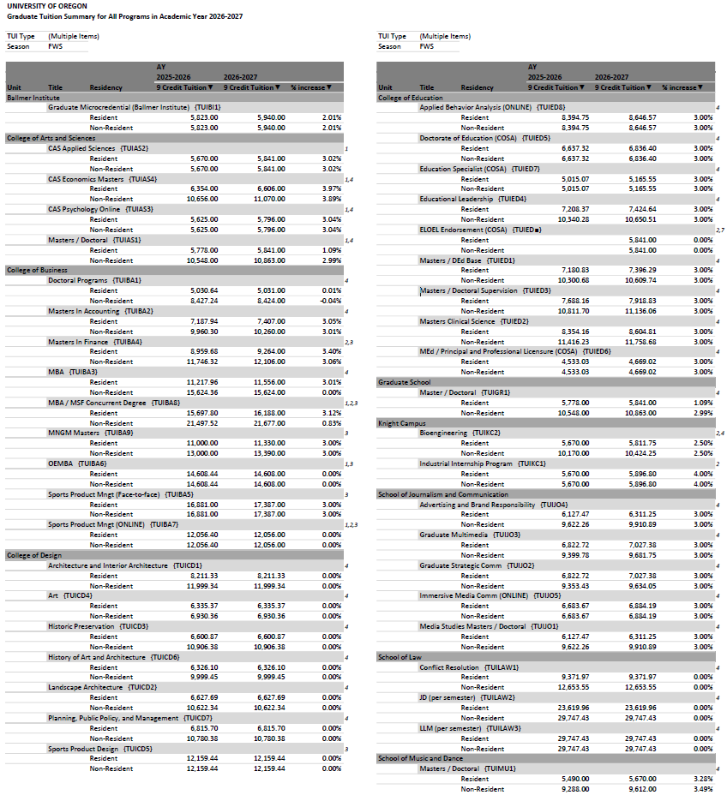
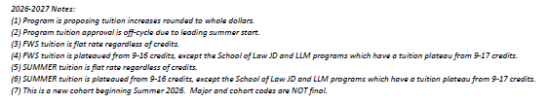
Appendix E: 2026-27 Academic Year Graduate Tuition Increase Proposals

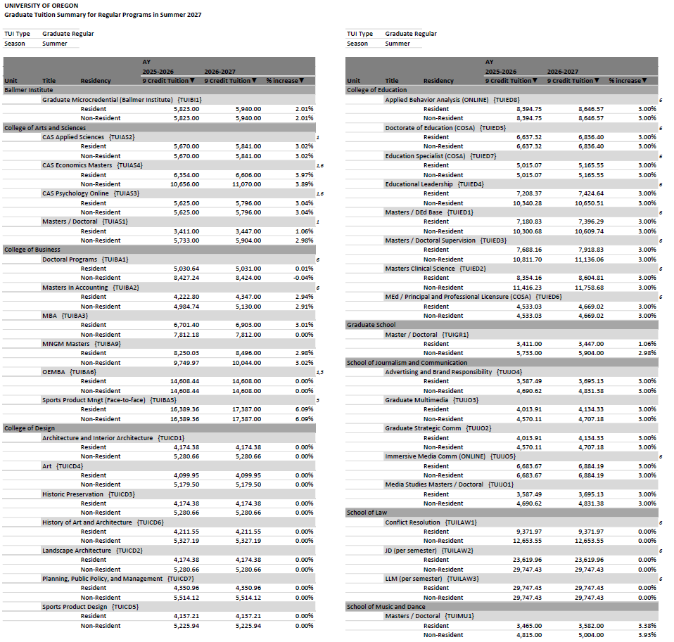
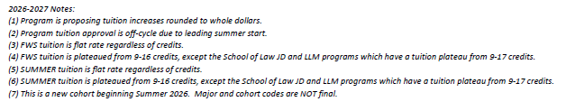
Appendix F: Summer 2027 Graduate Tuition Increase Proposals

Appendix G: Summer Term 2026 Graduate Off-Cycle Tuition Increase Proposals

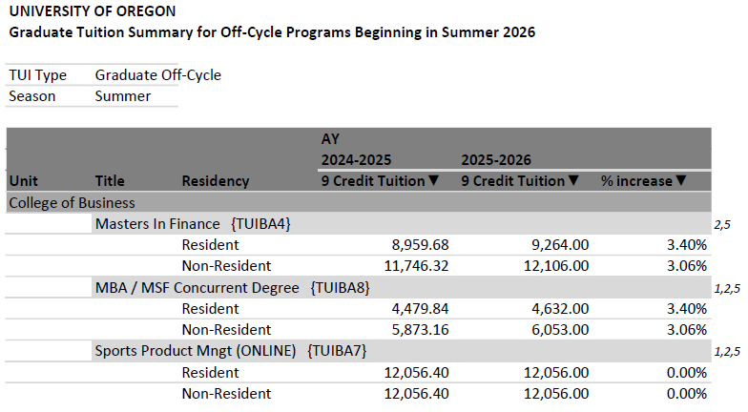

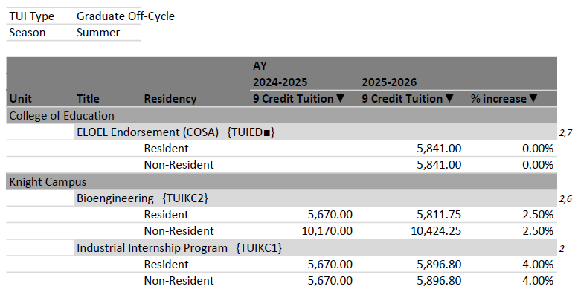
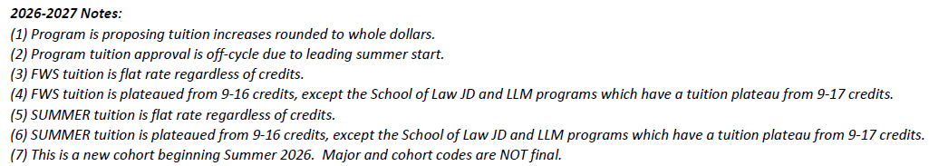

Appendix H: Lundquist Differential Tuition Proposal

To: Tuition and Fees Advisory Board

From: Bruce Blonigen, Edward Maletis Dean, Lundquist College of Business

Date: January 10, 2026

Subject: Increasing Lundquist differential tuition from $30 to $50 per student credit hour

Strategic rationale for differential tuition
More than half of public research universities now charge some form of differential tuition for business education,¹ and the rate of adoption has been increasing steadily for decades. The revenue generated by that tuition is used to deliver services that prepare students to succeed in business fields.

There are at least two key reasons why differential tuition has become so common for business schools. The first is cost-based. Business schools are required to rapidly adapt to both technological and industrial change and to the demands of employers and students for knowledge and skills that are relevant and applicable immediately after graduation. Differential tuition pays for the additional cost of the tools and the expertise to make that possible. The market for high-quality business faculty, who are experts in these specialized business tools, is also very competitive (because of private industry options), further increasing costs. The second reason is student-based. There is an increasing expectation by business majors for additional, specialized services for both their academic success and their career outcomes. As such, it is highly common for business schools to have their own academic advising staff, tutoring staff, and career center.

At the University of Oregon, demand for business education has been growing and is poised to continue to grow. Since 2019, total undergraduate student credit hours offered by the college have increased by 33%, majors by 39% and minors by 25%. In this year’s incoming class, 25% are declared business or pre-business majors. At the same time, the recent budget cuts are threatening Lundquist College’s ability to provide the same high-quality education and student services we have offered in the past. And it is clear that there are significant financial headwinds for the foreseeable future. Because the college is such a major attractor for prospective students, this is not just a threat to the college, but to the university. We are in intense competition for prospective students who want to major in business and are considering the strong business schools at our comparators.

In short, business education is high cost, but also in high demand because students and their families place long-term value on a business education. Thus, it makes sense that there is a tuition differential for business education relative to other majors on campus.

In the past, we have worked hard to keep differential tuition for the business school very low relative to our comparators. However, given the financial situation UO faces and the concern over the service levels we have for our students (e.g., our advising ratios are now over 800 students per advisor, which is the highest across all units at the university), we are proposing an increase that will put us closer to the average differential tuition of our business school comparators. This will help us not only keep student services at a level expected by the market but also allow us to hire enough faculty to keep class sizes from increasing.

As with any tuition increase, we are concerned about access. Because of this, we will dedicate 10% of the differential tuition revenues to Pathway Oregon scholarships. Additionally, we distribute over $1 million annually in scholarship dollars to our undergraduate students. Increasing these dollars is also a priority for our fundraising efforts. Maintaining and strengthening student services will help us better accomplish our Oregon Rising goals of timely graduation and career readiness for our students.
Because of guaranteed tuition, which includes differential tuition, this increase will not affect current students. If implemented, this higher level (from $30 to $50 per credit hour) will only be applied to first-year students in fall 2026 and then applied to any new students after fall 2026.

In the following, we first provide more details on the services valued by our students, and which are important when prospective students compare business schools. We then discuss the issue of affordability created by differential tuition and our strategies to provide aid to those who need it. We have discussed this proposal with current students in Lundquist and will describe those conversations. Finally, we provide comparator data that shows our proposed level of differential tuition will continue to place us at a reasonable level of differential tuition for a business school.

Value to Students and Quality of Student Experience
Revenues from differential tuition will be dedicated to student success. Students who take courses at Lundquist benefit from faculty who possess the education and professional expertise to prepare them to succeed in the workplace. Our highly qualified research faculty are complemented by professionals from a range of industries who bring real-world insights into the classroom. Our undergraduate curriculum is constantly updated to incorporate emergent topics such as artificial intelligence, data analytics, and changes to professional certification exams, such as those to become a Certified Public Accountant. To recruit qualified faculty, the reality of the market dictates compensation at higher rates than the average for the university. Differential tuition is a means to align that additional cost with the population that benefits from it.

Differential tuition revenues will also fund many important student services. All students who are part of our undergraduate pre-major, major or minor courses of study have access to academic advising and career development resources provided by the college. Our academic and career advising staff spend the majority of their time interacting directly with students. Their coordinated objective is to help students map out an academic journey and career plan that maximizes the benefit they receive from their time at Lundquist. Due to enrollment growth, our advisor to student ratio is above 800/1, which is well outside of best practice. Differential tuition will help us add needed capacity.

We offer multiple first-year programs for students interested in business, such as the Business Academic Residential community (BizARC), a summer bridge program, and a peer mentoring program called Flight School. Interest in Flight School has more than tripled since the last academic year, and we have had to cap the number of students who can join the program until we can devise ways to increase capacity. We operate a robust tutoring program designed to help students in our pre-business core classes, which include courses outside of the college, such as math and economics, so students can master the material and achieve good grades.

As is typical for all good business schools, our staff in career services not only provide career advising but actively build employer, recruiter, and alumni networks to get our students jobs. We have two industry recruiters (down from three, due to budget constraints) who build relationships with key employers of our graduates, facilitate internship opportunities and interviews for our students, and host major employer connection events throughout the year. Our alumni engagement staff complement this work by systematically leveraging our alumni network to help our students find mentors, internships, and post-graduation jobs.

We have also invested in technology tools that help students build and refine their resume, video and evaluate their interview skills, more easily connect with alumni, and otherwise accelerate their career readiness. This enables the college to serve a large and steadily increasing population of students with a relatively small number of staff. Responding to industry demand, we have also been at the forefront of integrating artificial intelligence tools and skills into our curriculum. We offer a series of short courses and seminars via the Professional Edge program covering timely topics and in-demand skills, including generative artificial intelligence, data analytics and visualization, sales skills, and project/time management. Participants can earn micro-credentials by participating in these courses, which are open free of charge to anyone on campus. The programs now also offer career immersions where teams of students engage in applied business projects developed by employers.

All our investments in student services converge on the linked goals of helping students move efficiently through the program to graduation and land great jobs when they are done. This translates to lower overall costs for students and their families and higher long-term earning potential. Importantly, all of our student success services are open to all pre-majors and majors, with most also available to business minors and other students on campus, including our tutoring services, the Professional Edge program, employer connection events, and most student clubs.

Addressing barriers to access
We understand that differential tuition can impact financial access to our business programs and degrees, but we are committed to doing as much as we can to mitigate this impact. First, the college is distributing approximately $1 million in scholarships to undergraduates annually. Our award rubric is designed to offer the highest levels of support to students who combine academic achievement with financial need. In addition, we commit to having 10% of the differential tuition go to the Pathway Oregon program for scholarships and other support to low-income Oregonian students served by that program. As mentioned, differential tuition also supports our bridge program and peer-mentoring program for first year students, which has been very important in providing access to underrepresented populations.

In our college, we also offer a separate pool of resources to help students with financial need who participate in experiential learning opportunities such as club memberships, industry conferences, and internships. We are currently conducting research into students who divert from our majors for reasons other than academic performance so that we can identify financial barriers or other factors that might be driving this choice and develop interventions to retain qualified students.

On a final note, we have been very active in fundraising as another avenue to support our faculty costs, support these important student services, and increase scholarship funds. We will continue these efforts and have had substantial success (averaging over $20 million annually in the past few years), but it hasn’t been enough, for example, to stop our staffing levels from declining as our number of majors has increased by over 40% in the last five years.

Discussion with students
Dean Bruce Blonigen met with the Dean’s Council for Inter-Club Coordination (DCICC) on October 10, 2025 to discuss the proposed increase to the differential tuition rate. Lundquist has many large, active student clubs and interest groups, which means student leaders in the DCICC represent a broad and diverse sample of Lundquist students. The students were generally supportive of the increase, citing the value they perceive in the additional services that the college offers and the importance of preserving and strengthening them. They see positive momentum across the college, with student club participation growing, excellent placement results for recent graduates, and innovative programs like Professional Edge and career immersions. They also view membership in the B1G as an exciting opportunity but noted that the college will need to continue to innovate and grow to keep pace with this new set of peers. They offered helpful feedback regarding the importance of clearly communicating how differential tuition revenue is used to benefit students, which we plan to incorporate into our overall plan for communicating with our undergraduate community. In summary, student feedback suggests that our business students understand these tradeoffs and prefer to pay a bit extra to preserve the high-quality teaching and student services we currently provide.
Our proposed differential tuition rate relative to other comparators
Many, if not most, public universities have a higher (differential) tuition rate for business curriculum relative to other majors. (Engineering is the other common major where higher differential tuition is typically charged.) As we show next, the data indicate that our proposed increase to a differential tuition rate of $50 per credit hour on Lundquist courses will continue to see us at a relatively low rate vis-à-vis relevant comparator institutions.

In making comparisons, it is important to understand that there are various ways that differential tuition is applied. While some schools apply a differential rate to credit hours for business courses, as we do, many other schools simply apply a differential charge each term to students who are declared business majors, effectively making all classes taken subject to a higher tuition rate. Schools also differ in when a student becomes a major. For some, students must be admitted as a major as they enter college, whereas others have a pre-major before students get admitted after year one or year two.

In order to make comparisons, we calculate the total cost of completing an undergraduate business major relative to the cost of an undergraduate major from the university’s College of Arts and Sciences. (Our research showed that the College of Arts and Science majors are always at the base tuition level for the university; i.e., no differential tuition). For our UO context, the proposed $50 differential tuition per credit hour for business courses means that it would cost a UO business major $4,400 more for their degree than a major from the College of Arts and Sciences. This is because the UO business major requires twenty-two four-credit courses from LCB for completion of the degree. Other courses required for the business major, but offered elsewhere at UO (e.g., economics, mathematics, and writing courses), would not have the differential tuition rate.

We note that our approach of charging differential tuition on Lundquist courses means that any UO student taking a Lundquist course will be assessed the differential tuition charge, including courses for the minors we offer. We think this is appropriate because it is the same higher-cost faculty who provide these courses and, as noted above, many of our student services are accessible for all UO students, including tutoring services, student clubs, the Professional Edge program, and some of our career readiness services.

State of Oregon Comparators
One set of relevant comparators is the other two major universities in the state, Oregon State and Portland State. Both of these institutions have differential tuition for a business major. Unlike UO, they both charge differential tuition for each term a student is a business major. It is common that students are admitted directly into the business school when they enter the university at both OSU and PSU, so that this additional per term charge is assessed the entire time a student is enrolled at the institution. Given this, we assume that the student is assessed differential tuition for four years (or twelve terms). Table 1 provides the total additional cost of a business major at the three major Oregon universities given these assumptions. As one can see, the additional cost for a business major with our proposal would be a bit higher than Portland State but lower than at Oregon State.
Table 1: Differential Tuition Comparators in State of Oregon
 | Differential Tuition Costs for Business Major¹ |  | Total Additional Costs for Business Major¹
 | Resident | Non-Resident | Resident | Non-Resident
Oregon State University | $432 per term | $432 per term | $5,184 | $5,184
Portland State University | $294 per term | $304 per term | $3,528 | $3,648
University of Oregon (Proposed) | $50 per business course credit | $50 per business course credit | $4,400 | $4,400
¹ Relative to costs for a major in the College of Arts and Sciences (or equivalent).
Note: Total additional costs calculations for Oregon State University and Portland State University assumes a student takes 16 credits a term and is a business major for four years (both schools generally directly admit students into the major in the first year), using AY25/26 tuition rates. Total additional costs for the University of Oregon multiplies the proposed $50 per course credit fee times the twenty-two four-credit business courses required for the major.

B1G Comparators
The UO relies heavily on attracting non-resident students, which means it is critical that we evaluate our differential tuition for a business major versus comparator out-of-state universities. One such set of comparators is the B1G schools, a group of schools that was top of mind when we discussed differential tuition with our UO business students, as mentioned above.

Table 2 provides the additional cost for a business major relative to a major from the College of Arts and Sciences from all other B1G universities. Two of the B1G schools (Northwestern and UCLA) do not offer an undergraduate business degree. Of the remaining fifteen schools, total differential tuition for a business degree is less in six schools and greater in nine of the schools, as compared to the proposed UO rate. The average differential cost for a business major across the 16 B1G schools with business majors (excluding UO) is $5,554 for in-state (resident) students and $6,155 for non-resident students. In summary, our proposed differential tuition cost of $4,400 would be lower than the average for B1G schools.

Table 2: Differential Tuition Comparators: B1G Schools from Lowest to Highest Cost
 | Differential Tuition Costs for Business Major¹ |  | Total Additional Costs for Business Major¹
 | Resident | Non-Resident | Resident | Non-Resident
University of Minnesota | $0 | $0 | $0 | $0
University of S. California | $0 | $0 | $0 | $0
University of Washington | $0 | $0 | $0 | $0
Michigan State University | $586 per year for years 3 & 4 | $618 per year for years 3 & 4 | $1,172 | $1,236
Rutgers University² | $225 per semester | $10.50 per semester | $1,800 | $84
Purdue University³ | $718 per semester | $718 per semester | $3,590 | $3,590
University of Oregon (Proposed) | $50 per business course credit | $50 per business course credit | $4,400 | $4,400
University of Nebraska⁴ | $69 per business course credit | $154 per business course | $5,037 | $11,242
Indiana University |  |  | $5,038 | $5,038
Pre-business | $775 per year | $775 per year
Business | $1,550 per year | $1,550 per year
University of Maryland | $3,214 per year for years 3 & 4 | $3,214 per year for years 3 & 4 | $6,428 | $6,428
Ohio State University² | $835 per semester | $835 per semester | $6,680 | $6,680
Pennsylvania State University | $4,714 per year for years 3 & 4 | $5,618 per year for years 3 & 4 | $9,428 | $11,236
University of Michigan |  |  | $9,904 | $10,792
Years 1 and 2 | $1,098 per year | $1,076 per year
Years 3 and 4 | $3,854 per year | $4,320 per year
University of Illinois⁵ | $2,690 per semester | $2,690 per semester | $10,760 | $10,760
University of Wisconsin² | $3,000 per year | $3,000 per year | $12,000 | $12,000
University of Iowa |  |  | $12,560 | $13,280
Years 1 and 2 | $2,154 per year | $2,217 per year
Years 3 and 4 | $4,126 per year | $4,423 per year
Northwestern University | Does not offer an undergraduate business degree
UCLA | Does not offer an undergraduate business degree
¹ Relative to costs for a major in the College of Arts and Sciences (or equivalent).
² Students are directly admitted into the business school as first-year students.
³ Assumes a transition from pre-major to major after semester 3 to calculate total additional costs.
⁴ Students must complete an average of 73 credits for the business major.
⁵ Assumes a transition from pre-major to major after sophomore year, as stated is typical.

The Ten AAU Public Universities with the Lowest Levels of State Support
The B1G schools are a relatively diverse set of universities in terms of financial context. Some (Northwestern and USC) are private institutions that charge relatively high base tuition levels, while others are public universities with very high levels of state support relative to the UO. For example, data from FY 2022 shows that the University of Minnesota receives $13,335 for each full-time equivalent (FTE) student, while the University of Oregon only receives $3,934 per student FTE. As discussed above, our financial context is an important factor for our differential tuition proposal.

To create a more apples-to-apples comparison, Table 3 provides data on differential tuition for business majors at the ten public universities in the American Association of Universities (AAU) that have the lowest level of state support. The table lists these by institution from lowest level of state support per student FTE to highest. First, one can see that UO receives the second lowest level of state support across all AAU universities. Second, all of these AAU universities with low levels of state support charge differential tuition for business majors and the average is much higher than what we observe across the B1G schools. Within this group, our proposed differential tuition of $50 per credit for business courses equates to less than half the cost of these comparators, which is perhaps the most comparable set for the UO in terms of academic quality and financial context.

Table 3: Differential Tuition Comparators: The Ten AAU Publics with the Lowest Level of State Support
 | Total Additional Costs for Business Major¹ |  | State Appropriations Per Student FTE (FY2022)²
 | Resident | Non-Resident
University of Colorado - Boulder | $24,288 | $15,952 | $3,163
University of Oregon (Proposed) | $4,400 | $4,400 | $3,934
Arizona State University | $4,960 | $8,520 | $4,933
University of Illinois | $10,760 | $10,760 | $4,936
Indiana University | $5,038 | $5,038 | $4,942
Purdue University | $3,590 | $3,590 | $6,299
University of Michigan | $9,904 | $10,792 | $6,536
Michigan State University | $1,172 | $1,236 | $6,597
University of Virgina | $24,280 | $25,356 | $6,835
University of Arizona | $5,625 | $8,100 | $7,691
Average (excluding UO) | $9,957 | $9,927 | $6,262
¹ Relative to costs for a major in the College of Arts and Sciences (or equivalent).
² Data from https://vpfa.uoregon.edu/tuition/aau-comparators.
Note 1: Total additional costs calculated for each school using the same assumptions as used in Table 2.
Note 2: Pennsylvania State University and University of Pittsburgh are excluded because they have different state funding mechanisms. Estimates would put them in this group of public AAU universities with lowest state support and they both have differential tuition for the business school majors, with residents paying $8,348 and $7,362 more for their business major at Penn State and Pittsburgh, respectively, and non-residents paying $11,236 and $15,822, respectively.

Auxiliary operations, such as the Student Recreation Center, the Erb Memorial (student) Union, Athletics, and Housing, earn revenue from the sale of products and services, and fees that covers their direct expenses, including any increases in the cost drivers. They also pay overhead to the institution to support central services they use.
The ASUO finalized the FY27 Incidental Fund Budget Recommendation in early February. An FY27 Incidental Fund Budget Recommendation, which meets the approval of the ASUO’s Legislative and Executive Branch, will be forwarded separately for your review.
Jordan Ackemann served throughout fall term and was replaced by Justin Begley in winter term.

