Peer Institutions
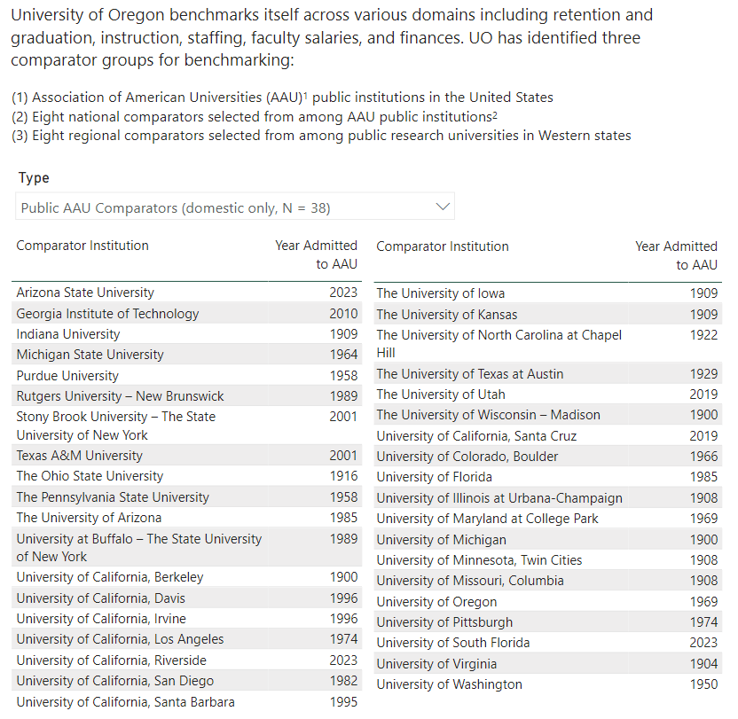
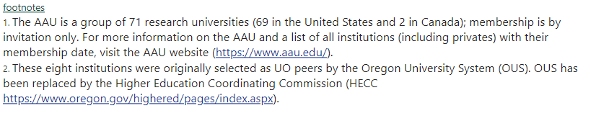

Source: https://ir.uoregon.edu/uo-overview/peer-institutions

