
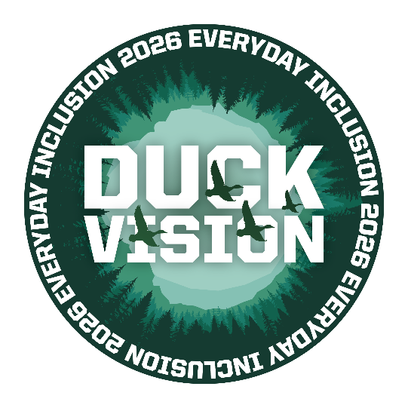
Everyday Inclusion 2026
Weekly Challenges
Week 3: January 20 - 23
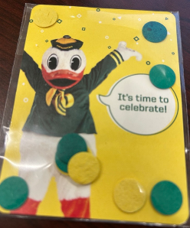
- PLANT some UO wildflower seeds. Message dsharp@uoregon.edu if you want wildflower confetti seeds for your team – you’ll also receive planting instructions from Jane Brubaker (CPFM Landscape Crew).
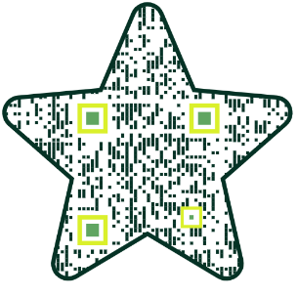
- IMMERSE yourself in Stargazer, a 25-minute visualization experience featuring imagery from the Webb and Hubble Space Telescopes. Find out how to enjoy Oregon’s largest screen in the Visualization Lab at the Price Sciences Library: https://uoregon.libcal.com/event/15968421
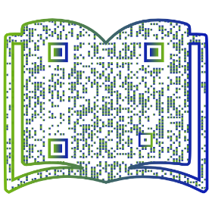
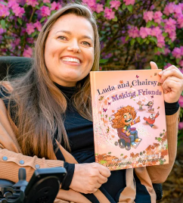
- EXPLORE how UO SOJC doctoral candidate Luda Gogolushko
worked to increase authentic representation of disability in media by founding a press focused on disabled authors and characters.

- MAKE your social media hashtags a lot easier to read by using UpperCamelCase – starting the first letter of each word with a capital letter. #AccessibilityMatters
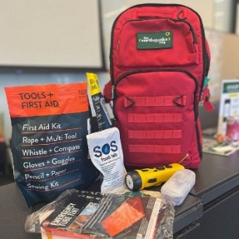
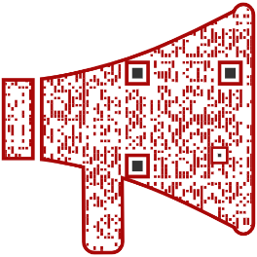
- GET ready for emergencies with an emergency management preparedness workshop from Safety and Risk Services. Join in person or online to learn about natural hazard risks, UO mitigation efforts, and the personal preparedness measures we can all take.

ACTIVITIES THIS WEEK – most involve virtual participation!

- Tues, Jan 20, 2-3pm: Tour of UOPD Dispatch Security Operations Center, Rm 271, 1715 Franklin Building
- Wed, Jan 21:
  - 10-11am: HYBRID Emergency Management Preparedness, with SRS (Rm 271, 1715 Franklin)
  - 12-12:20pm: ONLINE Midday Mindfulness, with Louise Hutson
- Thurs, Jan 22, 1-2pm: ONLINE Quack the Quiz, with Alex Milshtein
- Fri, Jan 23, 1:30-3pm: ONLINE Meditations on Flourishing, with UO Center for Science & Well-Being

**Register in MyTrack or contact Debbie Sharp at dsharp@uoregon.edu/541-346-3096 to sign up**
Everyday Inclusion 2026: https://vpfa.uoregon.edu/everyday-inclusion-2026-duck-vision
MyTrack: https://uomytrack.pageuppeople.com/learning/

