


Weekly Challenges
Week 2: January 12-16


- DISCOVER the history of Chinese immigrants who helped shape Oregon by signing up for an in-person, curator-led tour of the Roots and Resilience exhibit at the Museum of Natural and Cultural History.
If you can’t join the tour, explore the virtual tour of the exhibit online: https://blogs.uoregon.edu/mnchexhibits/roots-and-resilience/
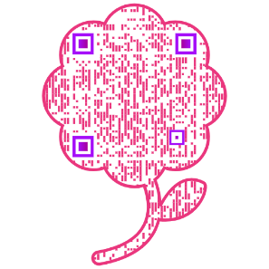

- CONSIDER the topic of flourishing. What is flourishing, anyway? We talk about it a lot, but do you really understand what we mean by flourishing at UO? Take a few minutes to learn more about how we define flourishing as part of Oregon Rising, including the five domains of flourishing and examples of each.

- IMPROVE your well-being with UO experts from the UO Center for the Science and Practice of Well-Being: https://www.wellbeingneuroscience.org/
The 90-minute session on Friday afternoon includes snacks and a chance to meditate on work well-being. Sign up using this QR code

- BUILD skills in MS SharePoint and learn how to create your own site to connect across teams, share resources, communicate highlights, and process change. Join Sue Russell, Director of the HR Community of Practice, to learn how the team built their SharePoint site.

- CELEBRATE the “Courage to Belong” at the 2026 Rev. Dr. Martin Luther King Jr. Commemoration and Awards Ceremony & lunch on Jan 22.
RSVP: https://inclusion.uoregon.edu/mlk-awards-nomination by Jan 16.

ACTIVITIES THIS WEEK
- Tues, Jan 13, 10-11am: Curator-led tour of the Roots and Resilience exhibit at MNCH
- Wed, Jan 14, 10-10:45am: Greenhouse facility tour (fully booked)
- Thu, Jan 15, 2-2:45pm: ONLINE tour of UO Human Resources SharePoint site, with Director Sue Russell
- Fri, Jan 16, 1:30-3pm: IN-PERSON session on Meditations on Flourishing in the EMU, rooms 231 & 232

**Register in MyTrack or contact Debbie Sharp at dsharp@uoregon.edu/541-346-3096 to sign up**
Everyday Inclusion 2026: https://vpfa.uoregon.edu/everyday-inclusion-2026-duck-vision
MyTrack: https://uomytrack.pageuppeople.com/learning/

