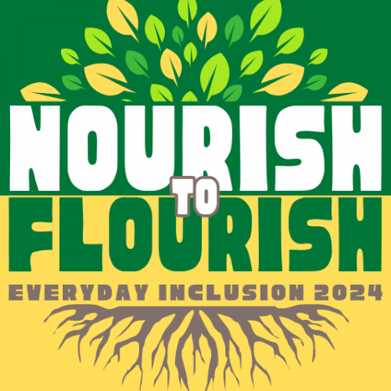


Weekly Challenges
Week 4: August 26-30


1. DISCOVER whether you are an introvert or an extrovert, and why it might matter. Take a quiz to find out (by Quiet author Susan Cain) https://susancain.net/quiet-quiz/ and learn more about the power of introverts: https://susancain.net/ted-talk/. If you enjoy the TED talk, email dsharp@uoregon.edu to sign up for a book discussion in October—we'll send you a copy of the book!
- LEARN how to make web content accessible: https://digitalaccessibility.uoregon.edu/training/web
President Scholz recommends the training for UO employees who create digital materials.

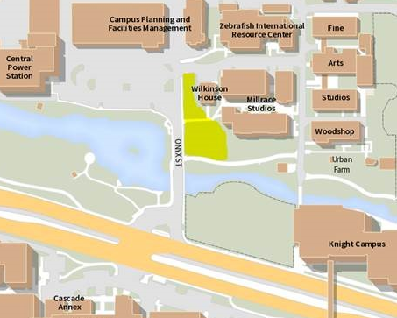
- ORGANIZE a UO campus tour for the team—in English or Spanish--by emailing Micah Howe (howem@uoregon.edu). Alternatively, try one of the seven campus tours available online at https://tourmaps.uoregon.edu/.

- JOIN us at the potluck on Thursday on the CPFM Wilkinson House Lawn for meeting, greeting, and lots of eating!

- DECORATE an Everyday Inclusion bag individually or with your team. We'll send you bags to decorate--you send us pictures of the decorated bags when you are done!
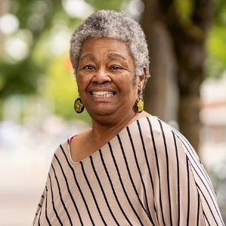
TAKE a moment to reflect on the life of Eugene's Lyllye Reynolds-Parker, who passed away on Thursday night. A leader in the city’s movement for racial justice, she was an academic advisor at the UO for
17 years and was instrumental in the establishment of the UO’s Black Cultural Center, which is named after her. https://dos.uoregon.edu/about-lrp

IN-PERSON AND VIRTUAL ACTIVITIES THIS WEEK
- Mon, Aug 26, 11am-12pm: Paint & Take tote bag activity in the CPFM Warehouse (no registration needed)
- Tues, Aug 27, 12:30-2pm: VIRTUAL Book Club discussion of Hijab Butch Blues (books still available)
- Wed, Aug 28, 1-2pm: In-person workshop on Healthy Boundaries (Anstett 191)
- Thurs, Aug 29, 11:30-1:30pm: No Pressure Portfolio Potluck (Wilkinson House Lawn)
- Fri, Aug 30, 10am-11am: VIRTUAL workshop on Healthy Boundaries
**Register in MyTrack or contact Debbie Sharp at dsharp@uoregon.edu/541-346-3096 to sign up**

