****[](https://vpfa.uoregon.edu/everyday-inclusion-2024-nourish-flourish)

**Weekly Challenges**

**Week 2: August 12-16**

[](https://oregonquarterly.uoregon.edu/protecting-first-foods-navigating-two-cultures)**1. LEARN about the importance of first foods and navigating two cultures from UO student Keyen Singer in a** [**seven-minute video**](https://oregonquarterly.uoregon.edu/protecting-first-foods-navigating-two-cultures) (scan the QR code🡪).

1. **SHARE something that is on your mind.**

**Listen to someone else share something that is on their mind.**

[](https://digitalaccessibility.uoregon.edu/training/content)

[](https://vpfa.uoregon.edu/vpfa-employee-spotlight)**3. SIGN** **UP** for the [**Digital Content Accessibility Training**](https://digitalaccessibility.uoregon.edu/training/content) to learn how to make Word docs, PDFs, emails, presentations, spreadsheets, and other content accessible to everyone.

1. **MEET** colleagues from across the portfolio through their recent[**employee spotlights**](https://vpfa.uoregon.edu/vpfa-employee-spotlight)**:** <https://vpfa.uoregon.edu/vpfa-employee-spotlight>

[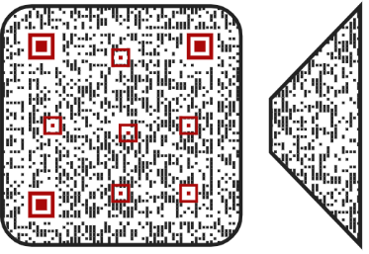](https://www.linkedin.com/learning/understanding-and-supporting-adhd-colleagues-in-the-workplace/supporting-adhders-in-meetings)

1. **EXPLORE** new ways to support colleagues with ADHD in meetings, by watching a [**3-minute video**](https://www.linkedin.com/learning/understanding-and-supporting-adhd-colleagues-in-the-workplace/supporting-adhders-in-meetings)**.**

**IN-PERSON AND VIRTUAL ACTIVITIES THIS WEEK**

* **Mon, Aug 12, 12-1pm**: Paint & Take bag activity, Room 271 (EOC) in 1715 Franklin (no need to register)
* **Tues, Aug 13, 7:30-8:30am**: Running Club with Drew Anderson (Meet at UO sign on Franklin & Agate)
* **Wed, Aug 14, 10-11:30am**: Sustainability Tour with Cimmeron Gillespie (Meet at Lillis south entrance)
* **Thurs, Aug 15, 1-2pm**: VIRTUAL Quack the Quiz trivia with Alex Milshtein (Transportation Services)
* **Fri, Aug 16, 11:15am-12:15pm**: JSMA guided tour of two current exhibitions (meet in JSMA lobby)

*\*\*Register in* [*MyTrack*](https://uomytrack.pageuppeople.com/learning/) *or contact Debbie Sharp at* [*dsharp@uoregon.edu*](mailto:dsharp@uoregon.edu)*/541-346-3096 to sign up\*\**

**Everyday Inclusion 2024**: <https://vpfa.uoregon.edu/everyday-inclusion-2024-nourish-flourish>