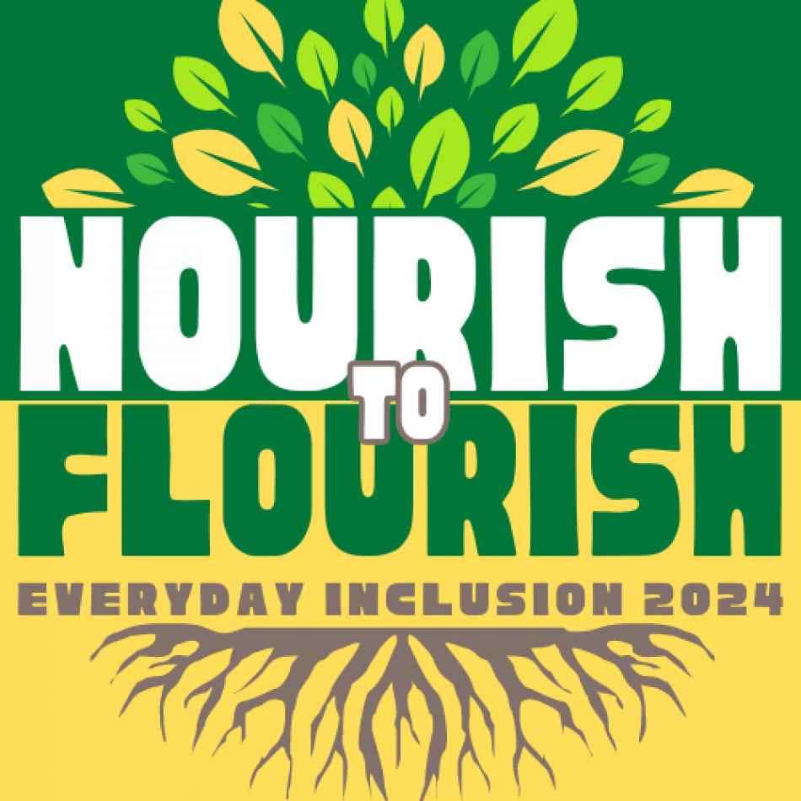


Weekly Challenges
Week 1: Aug 5-9

- CHECK out the activities on offer this week. Show up for an activity, such as the Paint and Take tote bag session at HR on the 4th Floor of PeaceHealth North (Monday, Aug 5, 12-1pm). Other Paint and Take sessions are taking place each Monday in August across campus.

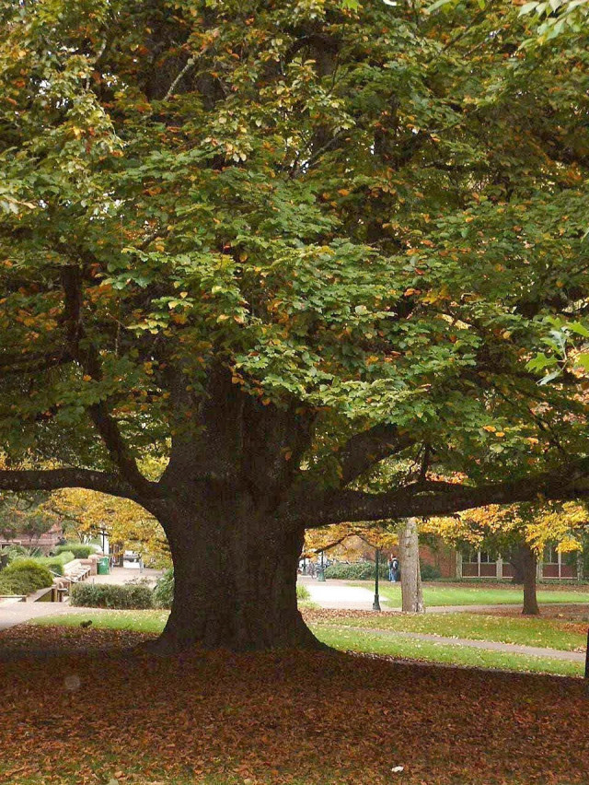
- EXPERIENCE the online campus Tree Tour as a precursor to Whitey Lueck’s guided on-campus version on Wed, Aug 7.

What is your favorite campus tree?

- DISCOVER the beauty of campus in "tree dimensions" and be reminded that the UO is a de-facto arboretum.

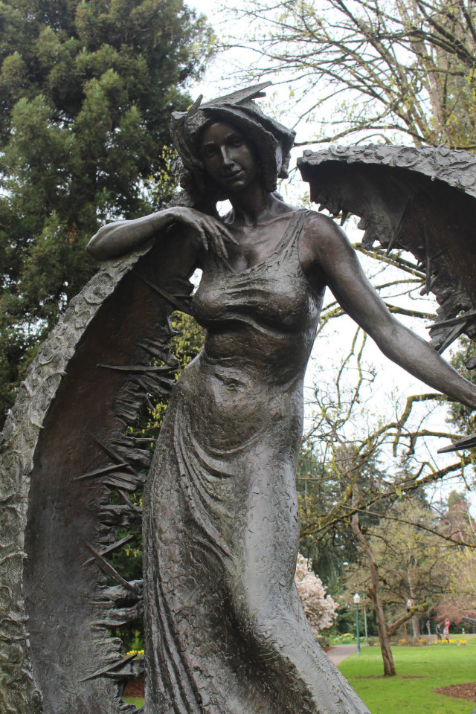
- BRAINSTORM what it means to flourish at work, in your team, in your daily life, and overall at the university.

- IMMERSE yourself in an online tour of Women in the History of the Campus Built Environment.
Then come see it all for yourself during the on-campus tour facilitated by CPFM folks on Friday, Aug 9, 9-10am.

IN-PERSON AND VIRTUAL ACTIVITIES THIS WEEK
- Mon, Aug 5, 12-1pm: Paint and Take tote bag activity, University HR (PeaceHealth North, 4th floor)
- Tues, Aug 6, 2-3pm: VIRTUAL Appreciative Inquiry - Accentuate the Positive, Deborah Butler (SVPFA Office)
- Wed, Aug 7, 9-11am: Tree Tour with Whitey Lueck
- Thurs, Aug 8, 12-1pm: VIRTUAL “Neurospicy Kid, Neurospicy Parent?” with Tamara Clark (Olum)
- Fri, Aug 9, 9-10am: Women in the History of the Campus Built Environment, with Liz Thorstenson (Campus Planning), and Janell Cottam and Renee Benoit (Design & Construction)

**Register in MyTrack or contact Debbie Sharp at dsharp@uoregon.edu/541-346-3096 to sign up**
Everyday Inclusion 2024: https://vpfa.uoregon.edu/everyday-inclusion-2024-nourish-flourish

