[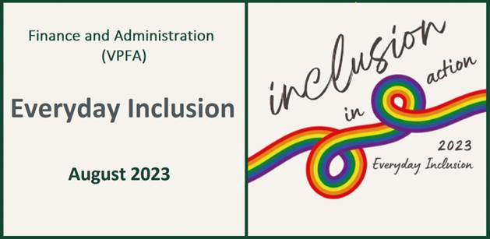](https://vpfa.uoregon.edu/everyday-inclusion-2023-inclusion-action)****

**Weekly Challenges Week 4: Aug 21-25**

1. **LEARN** more about [**how neurodiverse employees experience the workplace**](https://link.pblc.me/c/730816248?alt_obj=hre&method=email&url=https%3A%2F%2Fcanopywell.com%2FWorkplace-Inclusivity-for-Neurodiverse-Employees&hash=9193ab&chk=0-c16dbe&u=b1cb72)and consider small changes that could help us all be more productive and connected.

<https://canopywell.com/Workplace-Inclusivity-for-Neurodiverse-Employees>

[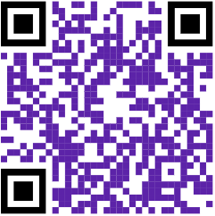](https://youtu.be/b1nJqpqgzR0)For example, is the lighting in our shared spaces optimized for all of us? In open work areas, can we designate a block of time for quiet work to minimize distractions? Consider attending [**Neurodiversity in the Workplace**](https://link.pblc.me/c/730816248?alt_obj=hre&method=email&url=https%3A%2F%2Fuomytrack.pageuppeople.com%2Flearning%2F3685&hash=bb052b&chk=0-c16dbe&u=b1cb72)with Jessica Michaels (online) on Aug 23rd.

1. **QUESTION your assumptions: about people on your team, other people you work with, people you interact with. Watch a 4-minute video about assumptions and having courage to speak up about inclusion:** <https://youtu.be/b1nJqpqgzR0>

**[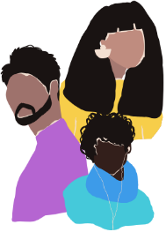](https://www.wecreatespace.co/glossary)**

1. **EXPLORE the Queer Allyship lexicon—an intersectional LGBTQ+ glossary of terms:** <https://www.wecreatespace.co/glossary>**. If you want to understand more about why pronouns are a big deal, join us to explore gender journeys with Dr. Megan Burke on Aug 24th at 1pm in the EMU.**

[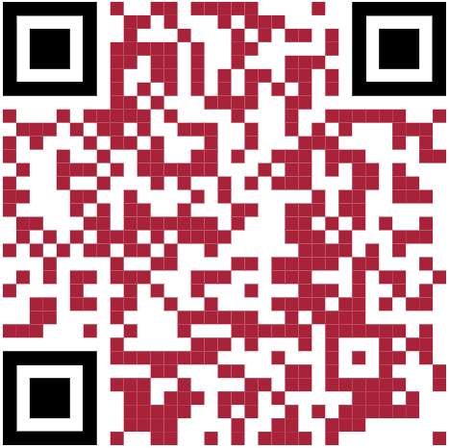](https://oregon.qualtrics.com/jfe/form/SV_40Bpzzvd1h9hVCB)

1. **REQUEST a** [pronoun ribbon for your name badge](https://oregon.qualtrics.com/jfe/form/SV_40Bpzzvd1h9hVCB)**. These ribbons stick to the bottom of your name badge to let others know your pronouns, and make it clear that you’d like to know their pronouns, too. While no one is required to share their pronouns, doing so openly creates an opportunity for others to share their pronouns with you, avoiding assumptions based on appearance.**
2. **INVITE** a colleague to coffee (in-person or remote) to find out more about the work they do. We are surrounded by experts in a broad range of topics. Asking questions to learn more about others (especially those who work outside of your department) is a great way to make a connection and better understand the variety of roles we each play in this complex organization.

**IN-PERSON AND VIRTUAL ACTIVITIES: This week**

* **Tues, Aug 22, 11am-12pm: *We Should All Be Feminists* book discussion, Chloe Barnett (HR) & Becks Jones (CPFM),**
* **Wed, Aug 23: 12-1pm: Neurodiversity in the Workplace, Jessica Michaels, online**
  + **1-2:30pm: How to make Small Talk with a Police Officer, John Johnson (UOPD), EMU Bartolotti's**
* **Thurs, Aug 24, 12-1pm: Trans 101, Dr. Megan Burke, EMU 023**
* **Fri, Aug 25, 2:30-3:30pm: Guided tour of exhibits in the Jordan Schnitzer Museum of Art (JSMA)**

*\*\*Register in MyTrack or contact Debbie Sharp at* [*dsharp@uoregon.edu*](mailto:dsharp@uoregon.edu)*/541-346-3096 to sign up\*\**

**Everyday Inclusion 2023**: <https://vpfa.uoregon.edu/everyday-inclusion-2023-inclusion-action>