**[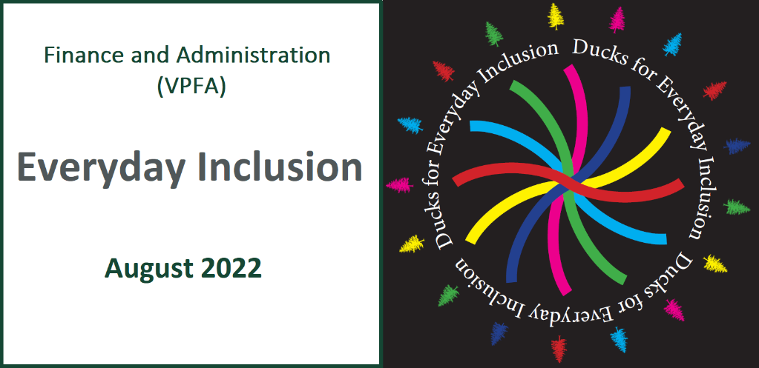](https://vpfa.uoregon.edu/everyday-inclusion-2022-connection-and-belonging)**

**Weekly Challenges Week 4:**

**August 22-26**

[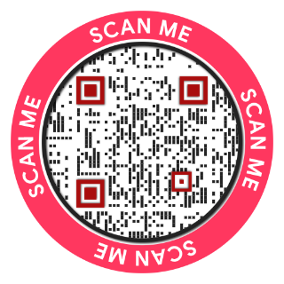](https://oregon.qualtrics.com/jfe/form/SV_cCMOPKwsLX8EoK2)Welcome to another week of [***Everyday Inclusion 2022***](https://link.pblc.app/c/538149777?alt_obj=hre&method=email&url=https%3A%2F%2Fvpfa.uoregon.edu%2Feveryday-inclusion-2022-connection-and-belonging&hash=ec69a1&chk=305640-d0548c). Thank you for showing up for this annual initiative.

In addition to the weekly challenges, there are two virtual activities taking place this week:

* 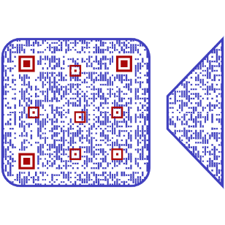Tuesday, 11am: **Disabilities and Technology: Introduction to Digital Accessibility**, with Grey L. Pierce, Digital Accessibility Architect, Information Services; register by email to [dsharp@uoregon.edu](mailto:dsharp@uoregon.edu).
* Thursday, 10am: **Creating Safe Spaces for Tough Conversations at Work**: A Facilitated Discussion on the [LinkedIn Learning Course](https://link.pblc.app/c/538149777?alt_obj=hre&method=email&url=https%3A%2F%2Fwww.linkedin.com%2Flearning%2Fcreating-safe-spaces-for-tough-conversations-at-work%2Fencountering-tough-conversations%3Fautoplay%3Dtrue%26u%3D68269554&hash=2e9e90&chk=305640-d0548c), Tiffany Lundy and Chloe Barnett, HR; register by email to [dsharp@uoregon.edu](mailto:dsharp@uoregon.edu).

We look forward to seeing you at an event!

--The VPFA diversity committee

[](https://oregon.qualtrics.com/jfe/form/SV_cCMOPKwsLX8EoK2)Bienvenidos a otra semana de [***Everyday Inclusion 2022***](https://link.pblc.app/c/538149777?alt_obj=hre&method=email&url=https%3A%2F%2Fvpfa.uoregon.edu%2Feveryday-inclusion-2022-connection-and-belonging&hash=ec69a1&chk=305640-d0548c) (Inclusión para Todos los Días). Muchas gracias por asistir a esta iniciativa anual.

Todavía quedan algunas formas de participar y todas las actividades de esta semana tienen lugar en el mundo virtual:

* Martes, 11a.m.: **Discapacidades y Tecnología: Introducción a la Accesibilidad Digital**, Gray L. Pierce, Arquitecto de Accesibilidad Digital; registrarse por Email ([dsharp@uoregon.edu](mailto:dsharp@uoregon.edu))
* Jueves, 10a.m.: **Servicios de Información Creación de Espacios Seguros para Conversaciones Difíciles en el Trabajo**: un Debate Moderado Sobre [el Curso de Aprendizaje de LinkedIn](https://link.pblc.app/c/538149777?alt_obj=hre&method=email&url=https%3A%2F%2Fwww.linkedin.com%2Flearning%2Fcreating-safe-spaces-for-tough-conversations-at-work%2Fencountering-tough-conversations%3Fautoplay%3Dtrue%26u%3D68269554&hash=2e9e90&chk=305640-d0548c), Tiffany Lundy y Chloe Barnett, RRHH; registrarse por Email ([dsharp@uoregon.edu](mailto:dsharp@uoregon.edu))

¡Esperamos verte en un evento!

*--El comité de diversidad de VPFA*

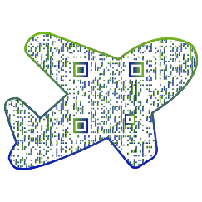****

5. **WRITE** a note or tell someone in person that you’ve noticed their great work. We all love to hear our efforts are noticed and appreciated.

**ESCRIBE** una nota o dile a alguien en persona que has notado su gran trabajo.

A todos nos encanta escuchar que nuestros esfuerzos son notados y apreciados.

[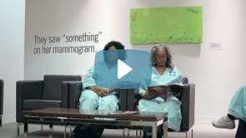](https://www.youtube.com/watch?v=cDDWvj_q-o8)

[4. **CONSIDER**](https://link.pblc.app/c/538184598?method=email&token=2120211AZjCY) the complex lives of people around you. They could be dealing with financial stress, celebrating a joyful milestone, managing addiction in their family, or worrying about upcoming life events.

[Be patient: we are all dealing with a lot.](https://link.pblc.app/c/538184598?method=email&token=2120211AZjCY)

2. **THINK** about support at work. We’ve all known someone at work who makes us feel comfortable, supported, and seen.

Think about who that person is for you, and then make a list of **three things** you can do to help create that same feeling for your coworkers.

**PIENSE** en el apoyo en el trabajo. Todos hemos conocido a alguien en el trabajo que nos hace sentir cómodos, apoyados y vistos.

Piense en quién es esa persona para usted y luego haga una lista de tres cosas que puede hacer para ayudar a crear ese mismo sentimiento para sus compañeros de trabajo.

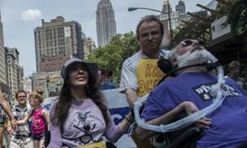

3. **READ** a [short article](https://link.pblc.app/c/538174640?alt_obj=hre&method=email&url=https%3A%2F%2Fwww.klcc.org%2Fnpr-news%2Fnpr-news%2F2022-08-08%2Fhow-to-talk-about-disability-sensitively-and-avoid-ableist-tropes&hash=9e9b85&chk=305640-d0548c) on best practices for discussing disability inclusively, such as:

* Centering disabled voices
* Recognizing disability as culture
* Understanding intersectionality

<https://bit.ly/3dRgxpL>

# [**WEEKLY CHALLENGES (Aug 22-26)**](https://link.pblc.app/c/535508001?method=email&token=2723990F_6HU)

**1. TRAVEL** the world through new eyes via a travel show, blog, or global radio app:

* [**Traveling While Black**](https://link.pblc.app/c/538149786?alt_obj=hre&method=email&url=https%3A%2F%2Fwww.youtube.com%2Fchannel%2FUCDmVoKCKBRr29V91B3nYRlA&hash=576094&chk=305640-d0548c): YouTube channel <https://bit.ly/3AedoHR> (or use QR code)
* [**Simply Emma**](https://link.pblc.app/c/538149786?alt_obj=hre&method=email&url=https%3A%2F%2Fwww.simplyemma.co.uk%2F&hash=9a03c0&chk=305640-d0548c): Wheelchair-accessible travel tips & resources <https://www.simplyemma.co.uk/>
* [**1Dad 1Kid**](https://link.pblc.app/c/538149786?alt_obj=hre&method=email&url=http%3A%2F%2F1dad1kid.com%2F&hash=af9409&chk=305640-d0548c): Single dad and daughter share stories and photos of world travel <http://1dad1kid.com/>
* [**Couple of Men**](https://link.pblc.app/c/538149786?alt_obj=hre&method=email&url=https%3A%2F%2Fcoupleofmen.com%2F&hash=7d9346&chk=305640-d0548c)**:** Karl and Daan’s blog sharing tales of traveling while gay <https://coupleofmen.com/>
* [**Radiooooo**](https://link.pblc.app/c/538149786?alt_obj=hre&method=email&url=http%3A%2F%2Fradiooooo.com%2F&hash=955dcf&chk=305640-d0548c): Click on a country & decade for music from that area and time <https://radiooooo.com/>

[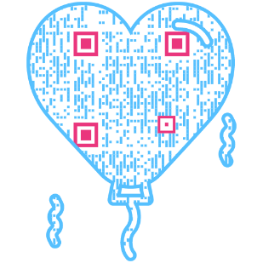](https://www.youtube.com/watch?v=cDDWvj_q-o8)

Find out more about *Everyday Inclusion 2022*:  
[https://vpfa.uoregon.edu/everyday-inclusion-2022-connection-and-belonging](https://link.pblc.app/c/538149778?alt_obj=hre&method=email&url=https%3A%2F%2Fvpfa.uoregon.edu%2Feveryday-inclusion-2022-connection-and-belonging&hash=ec69a1&chk=305640-d0548c)