**[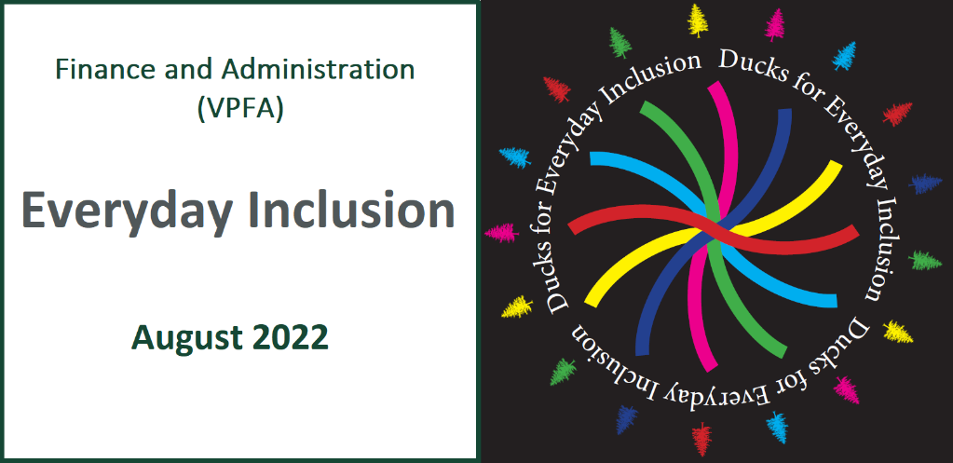](https://vpfa.uoregon.edu/everyday-inclusion-2022-connection-and-belonging)**

**Weekly Challenges Week 3: August 15-19**

[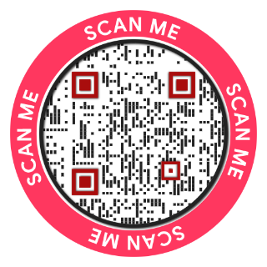](https://oregon.qualtrics.com/jfe/form/SV_cCMOPKwsLX8EoK2)We are halfway into [***Everyday Inclusion 2022***](https://vpfa.uoregon.edu/everyday-inclusion-2022-connection-and-belonging) and hope you’ve had a chance to engage.

If you’re unable to participate in diversity committee [activities](https://link.pblc.app/c/535504024?alt_obj=hre&method=email&url=https%3A%2F%2Fvpfa.uoregon.edu%2Feveryday-inclusion-2022-connection-and-belonging%23Three&hash=b79867&chk=304850-2af4ae), you can still join in an activity with your team, or engage individually with the [weekly challenges](#_WEEKLY_CHALLENGES_(Aug). Complete the [participation survey](https://oregon.qualtrics.com/jfe/form/SV_cCMOPKwsLX8EoK2) to share what you’ve done, or drop us [an email](mailto:dsharp@uoregon.edu?subject=I%20participated%20in%20Everyday%20Inclusion%202022!) to tell us you are participating. We’ll send you a Ducks for Diversity sticker via Campus Mail!

[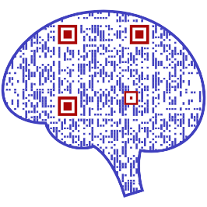](https://mpembed.com/show/?m=HKdTBb2CAiF&mpu=885)Activities this week focus on in-person tours of the [Lyllye Reynolds-Parker Black Cultural Center](https://link.pblc.app/c/535504025?alt_obj=hre&method=email&url=https%3A%2F%2Fuomytrack.pageuppeople.com%2Flearning%2F&hash=af9ab0&chk=304850-2af4ae) and exhibitions at the [Jordan Schnitzer Museum of Art](https://link.pblc.app/c/535504025?alt_obj=hre&method=email&url=https%3A%2F%2Fuomytrack.pageuppeople.com%2Flearning%2F&hash=af9ab0&chk=304850-2af4ae). If you prefer to enjoy these spaces remotely, check out this information:

[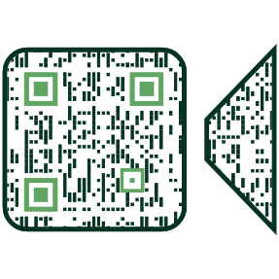](https://dos.uoregon.edu/bcc)🡨 Watch the [2-min walk-through video on the BCC](https://dos.uoregon.edu/bcc)

JSMA exhibit: [Hung Liu: Remember This (virtual tour)](https://mpembed.com/show/?m=HKdTBb2CAiF&mpu=885) 🡪

Good luck with this week’s challenges!

--The VPFA diversity committee

[](https://oregon.qualtrics.com/jfe/form/SV_cCMOPKwsLX8EoK2)

Estamos a mitad de camino en [***Everyday Inclusion 2022***](https://vpfa.uoregon.edu/everyday-inclusion-2022-connection-and-belonging) (Inclusión para Todos los Días) y esperamos que haya tenido la oportunidad de participar.

Si no puede participar en las [actividades del comité de diversidad](https://link.pblc.app/c/535504024?alt_obj=hre&method=email&url=https%3A%2F%2Fvpfa.uoregon.edu%2Feveryday-inclusion-2022-connection-and-belonging%23Three&hash=b79867&chk=304850-2af4ae), aún puede participar en una actividad con su equipo o participar individualmente en [los desafíos semanales](#_WEEKLY_CHALLENGES_(Aug). Complete [una encuesta de participación](https://oregon.qualtrics.com/jfe/form/SV_cCMOPKwsLX8EoK2) para compartir lo que ha hecho o envíenos [un correo electrónico](mailto:dsharp@uoregon.edu?subject=I%20participated%20in%20Everyday%20Inclusion%202022!) para decirnos que está participando. ¡Le enviaremos una calcomanía de Ducks for Diversity (Patos por la Diversidad) a través de Campus Mail!

[](https://dos.uoregon.edu/bcc)[](https://mpembed.com/show/?m=HKdTBb2CAiF&mpu=885)Las actividades de esta semana se centran en recorridos por el [Centro Cultural Negro de Lyllye Reynolds-Parker](https://link.pblc.app/c/535504025?alt_obj=hre&method=email&url=https%3A%2F%2Fuomytrack.pageuppeople.com%2Flearning%2F&hash=af9ab0&chk=304850-2af4ae) (BCC) y exposiciones en el [Museo de Arte de Jordan Schnitzer](https://link.pblc.app/c/535504025?alt_obj=hre&method=email&url=https%3A%2F%2Fuomytrack.pageuppeople.com%2Flearning%2F&hash=af9ab0&chk=304850-2af4ae) (JSMA). Si prefieres disfrutar de estos espacios a distancia, consulta esta información:

🡨 Mire [el video de recorrido de 2 minutos en el BCC](https://dos.uoregon.edu/bcc)

Exhibicione JSMA: [Hung Liu: Recuerda esto (recorrido virtual)](https://mpembed.com/show/?m=HKdTBb2CAiF&mpu=885) 🡪

¡Buena suerte con los desafíos de esta semana!

--El comité de diversidad de VPFA



5. **MAKE** your next email a phone call or in-person conversation. Stepping away from the screen for a minute can be a refreshing and personal way to connect.

**HAGA** de su próximo correo electrónico una llamada telefónica o una conversación en persona.

Alejarse de la pantalla por un minuto puede ser una forma refrescante y personal de conectarse.

[4. **EXPLORE**](https://link.pblc.app/c/535504029?method=email&token=2710037aET5A) the strategies groups building community at the UO and consider joining one of them:<https://inclusion.uoregon.edu/strategy-groups>

2. **ASK** a coworker to take a walk with you. Even 15 minutes is a great opportunity to step away from your work and connect with someone.

**PIDA** a un compañero de trabajo que dé un paseo con usted.

Incluso 15 minutos es una gran oportunidad para alejarse de su trabajo y conectarse con alguien.

[](https://www.apa.org/about/apa/equity-diversity-inclusion/language-guidelines)

3. **BOOKMARK** and refer to the [APA inclusive language guide](https://www.apa.org/about/apa/equity-diversity-inclusion/language-guidelines) to ensure you communicate in ways that center perspectives of people who are often marginalized or stereotyped.

# [**WEEKLY CHALLENGES (Aug 15-19)**](https://link.pblc.app/c/535508001?method=email&token=2723990F_6HU)

[1. **DELVE**](https://link.pblc.app/c/535508001?method=email&token=2723990F_6HU) [into Native American and Indigenous history and experiences at the UO:](https://inclusion.uoregon.edu/indigenous-uo-campus-map)

* While remote: Explore the [Indigenous UO Campus Map](https://inclusion.uoregon.edu/indigenous-uo-campus-map)
* In the Knight Library lobby: Visit the [*Unceded Kinship – Land, Place, and People*](https://link.pblc.app/c/535508001?alt_obj=hre&method=email&url=https%3A%2F%2Fcalendar.uoregon.edu%2Fevent%2Funceded_kinship_land_place_people%23.YvQxJXbMKUk&hash=4bcf8d&chk=304850-2af4ae) exhibit, which celebrates Indigenous Sovereignty and Black Liberation.

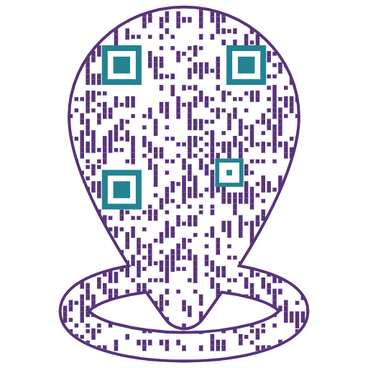

[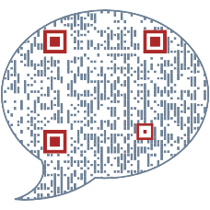](https://www.apa.org/about/apa/equity-diversity-inclusion/language-guidelines)

[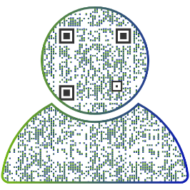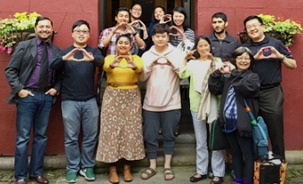](https://inclusion.uoregon.edu/strategy-groups)

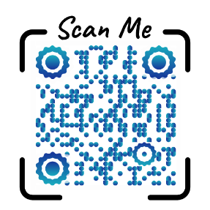

**IN-PERSON ACTIVITIES: This week**

* Lyllye Reynolds-Parker Black Cultural Center tours
  + **Tues, Aug 16, 1-1:45pm**
  + **Thurs, Aug 18, 11-1145am**
* Jordan Schnitzer Museum of Art (JSMA): Reflections on History, Memory, and Identity: A Tour of Hung Liu, Lewis Watts, and Sara Siestreem
  + **Wed, Aug 17, 9-10am**
  + **Fri, Aug 19, 3-4pm**

**Register in [MyTrack](https://uomytrack.pageuppeople.com/learning/) by scanning the QR code (log in with Duck ID) or contact Debbie Sharp at [dsharp@uoregon.edu 541-346-3096](mailto:dsharp@uoregon.edu%20541-346-3096) to sign up**