**[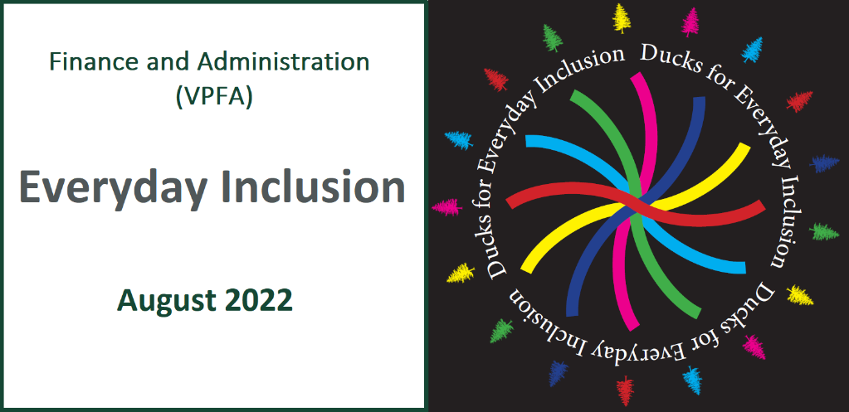](https://vpfa.uoregon.edu/everyday-inclusion-2022-connection-and-belonging)**

**Weekly Challenges Week 2: August 8-12**

[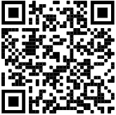](https://oregon.qualtrics.com/jfe/form/SV_cCMOPKwsLX8EoK2)Welcome to the second week of [Everyday Inclusion 2022](https://link.pblc.app/c/532361662?alt_obj=hre&method=email&url=https%3A%2F%2Fvpfa.uoregon.edu%2Feveryday-inclusion-2022-connection-and-belonging&hash=ec69a1&chk=303596-917bf7). If you haven't yet completed the participation survey, [please take a minute to do that](https://oregon.qualtrics.com/jfe/form/SV_cCMOPKwsLX8EoK2).

There are two in-person tours and two virtual learning sessions this week. There are still spots available for the on-campus Women in the History of the Campus Built Environment tour on [Thursday (10am)](mailto:dsharp@uoregon.edu?subject=Register%20for%20Women's%20History%20Tour%208/11@10am&body=Please%20sign%20me%20up%20for%20the%20Women's%20History%20Tour,%20Thurs,%20Aug%2011,%2010am). You can also learn about inclusion at play with Early Childhood CARES ([Tues, 11am](mailto:dsharp@uoregon.edu?subject=Register%20for%20EC%20Cares%20Overview%208/10@11am&body=Please%20sign%20me%20up%20for%20the%20EC%20CARES%20overview%20session%20on%20Wed,%20Aug%2010%20from%2011am)) or the anti-bias approach to child development ([Fri, 12pm](mailto:dsharp@uoregon.edu?subject=Register%20for%20They%20Are%20Not%20Too%20Young%208/12@12pm&body=Please%20sign%20me%20up%20for%20They%20Are%20Not%20Too%20Young,%20Fri,%20Aug%2012,%2012pm))--both from the comfort of your digital device.

We also have a new set of challenges for you this week. We hope they help increase connections and foster a greater shared sense of belonging at work.

We're pleased you are here.

--The VPFA diversity committee

[](https://oregon.qualtrics.com/jfe/form/SV_cCMOPKwsLX8EoK2)Bienvenido a la segunda semana de [*Everyday Inclusion 2022*](https://link.pblc.app/c/532361662?alt_obj=hre&method=email&url=https%3A%2F%2Flink.pblc.app%2Fc%2F532361662%3Falt_obj%3Dhre%26method%3Demail%26url%3Dhttps%253A%252F%252Fvpfa.uoregon.edu%252Feveryday-inclusion-2022-connection-and-belonging%26hash%3Dec69a1%26chk%3D303596-917bf7&hash=fc6c3f&chk=303596-917bf7) *(Inclusión para Todos los Días)*. Si aún no ha completado la encuesta de participación, [tómese un minuto para hacerlo](https://oregon.qualtrics.com/jfe/form/SV_cCMOPKwsLX8EoK2).

Hay dos recorridos en persona y dos sesiones de aprendizaje virtual esta semana. Todavía hay lugares disponibles para la visita presencial Mujeres en la Historia del Entorno Construido del Campus el [jueves (10 a.m.)](mailto:dsharp@uoregon.edu?subject=Register%20for%20Women's%20History%20Tour%208/11@10am&body=Please%20sign%20me%20up%20for%20the%20Women's%20History%20Tour,%20Thurs,%20Aug%2011,%2010am). También puede obtener información sobre la inclusión en acción con Early Childhood CARES ([martes, 11 a.m.](mailto:dsharp@uoregon.edu?subject=Register%20for%20EC%20Cares%20Overview%208/10@11am&body=Please%20sign%20me%20up%20for%20the%20EC%20CARES%20overview%20session%20on%20Wed,%20Aug%2010%20from%2011am" \t "_blank)) o el enfoque antisesgo para el desarrollo infantil ([viernes, 12 p.m.](mailto:dsharp@uoregon.edu?subject=Register%20for%20They%20Are%20Not%20Too%20Young%208/12@12pm&body=Please%20sign%20me%20up%20for%20They%20Are%20Not%20Too%20Young,%20Fri,%20Aug%2012,%2012pm" \t "_blank)), ambos desde la comodidad de su dispositivo digital.

También tenemos un nuevo conjunto de desafíos para ti esta semana. Esperamos que ayuden a aumentar las conexiones y fomentar un mayor sentido compartido de pertenencia en el trabajo.

Estamos contentos de que estés aquí.

--El comité de diversidad de VPFA

****

[](https://hbr.org/2021/12/3-small-ways-to-be-a-more-inclusive-colleague)**[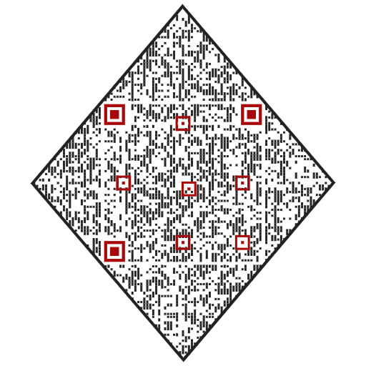](https://hbr.org/2021/12/3-small-ways-to-be-a-more-inclusive-colleague)**

5. **READ** a [short article](https://hbr.org/2021/12/3-small-ways-to-be-a-more-inclusive-colleague) on how to be a more inclusive colleague (scan QR code).

[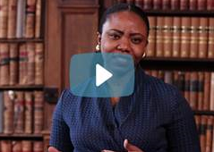](https://www.youtube.com/watch?v=jtJkIjUQHtE)**[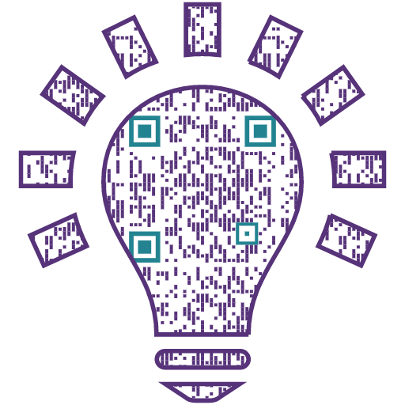](https://www.youtube.com/watch?v=jtJkIjUQHtE)**

4. **WATCH** a [10-minute video](https://www.youtube.com/watch?v=jtJkIjUQHtE) on three ways to be more inclusive at work.

1. **LISTEN**.

Just listen. If your co-worker shares a story or something about their work, their difficulties, their day, their pets, their child, their life...whatever it is...just listen.

**ESCUCHA**.

Sólo escucha. Si su compañero de trabajo comparte una historia o algo sobre su trabajo, sus dificultades, su día, sus mascotas, su hijo, su vida... lo que sea... simplemente escuche.

[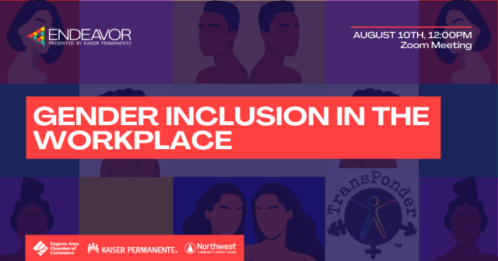](https://web.eugenechamber.com/events/Endeavor-Gender-inclusion-in-the-workplace-2318518/details)

2. **SIGN UP** for a free virtual workshop on [Gender Inclusion in the Workplace](https://link.pblc.app/c/532361665?alt_obj=hre&method=email&url=https%3A%2F%2Fweb.eugenechamber.com%2Fevents%2FEndeavor-Gender-inclusion-in-the-workplace-2318518%2Fdetails&hash=b90465&chk=303596-917bf7), by Eugene Chamber of Commerce: Wed, Aug 10, 12-1pm.

3. **CONSIDER** what it might feel like to be a minority in the workplace. What might it feel like to be the only veteran, blind person, woman of color, person who grew up in a rural environment, older worker, non-US citizen, strong Christian, person struggling with money problems, single parent?

**CONSIDERE** cómo se sentiría ser una minoría en el lugar de trabajo. ¿Cómo se sentiría ser la única veterana, mujer de color, ciega, persona que creció en un entorno rural, trabajadora mayor, no ciudadana de los EE. UU., cristiana fuerte, persona que lucha con problemas de dinero, madre soltera...?

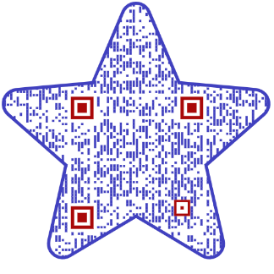

**IN-PERSON AND VIRTUAL ACTIVITIES: This week**

* **Tues, Aug 9, 11-11:45am**: Black Cultural Center tour (*few spots remain*; two BCC tours next week)
* **Wed, Aug 10, 11-11:50am**: Early Childhood CARES: Inclusion at Play, Nellie Huggins, *virtual*
* 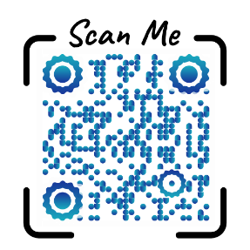**Thurs, Aug 11, 10-11:30am**: Women in the History of the Campus Built Environment, Liz Thorstenson & Renee Benoit (Campus Planning) and Jane Brubaker (CPFM Facilities), meet at EMU amphitheater
* **Fri, Aug 12, 12-1pm**: They are Not Too Young – Raising Children in a Diverse World, Tamara Clark (Vivian Olum Child Development Center), *virtual*

\*\*Register in [MyTrack](https://uomytrack.pageuppeople.com/learning/) by scanning the QR code and logging in with your Duck ID

Or contact Debbie Sharp at [dsharp@uoregon.edu/541-346-3096](mailto:dsharp@uoregon.edu/541-346-3096) to sign up\*\*