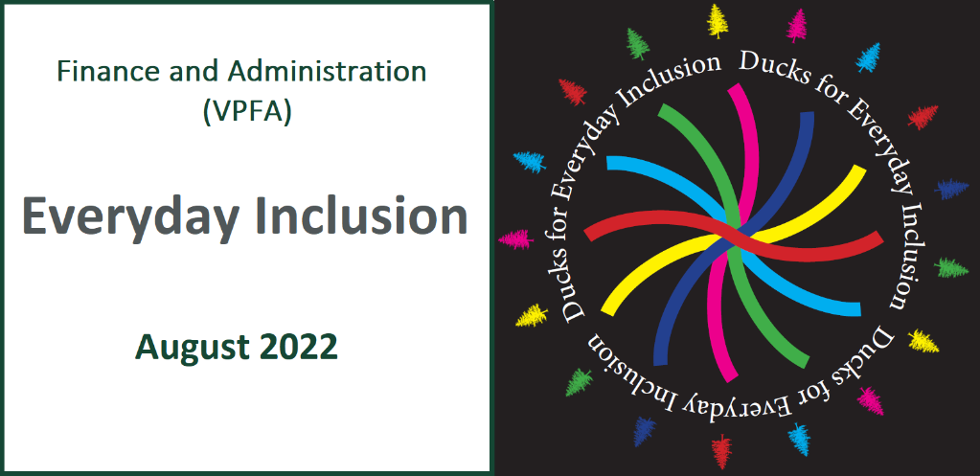

Weekly Challenges Week 1: August 1-5

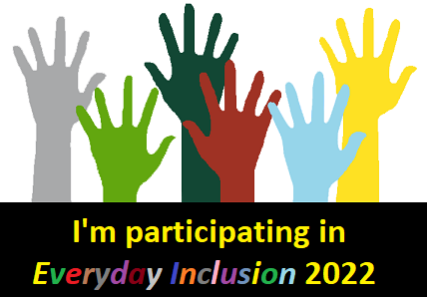
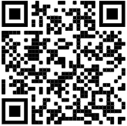
- COMPLETE the commitment survey to let us know you are participating in Everyday Inclusion 2022. Everyone who joins us on the journey will receive a Ducks for Everyday Inclusion sticker!
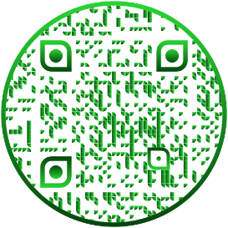
2. LEARN about pronouns and why they matter for many people. Watch this 2-minute video to learn how easy it is to show respect and get pronouns right, and understand more about why this is an important issue to many people.
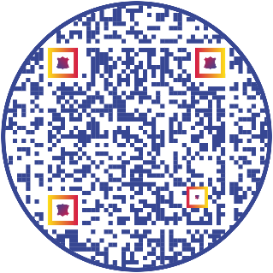
3. INVITE members of another department to lunch OR get yourself invited to lunch at another department.

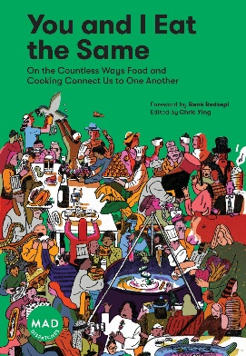
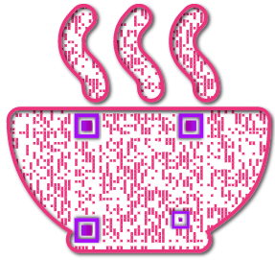
4. READ about the importance of having conservative voices on liberal campuses: https://admissions.tufts.edu/blogs/jumbo-talk/post/having-a-conservative-voice-on-a-liberal-campus/

5. CONTRIBUTE a recipe and reflection as part of the Foods that Connect Us initiative.
(https://vpfa.uoregon.edu/everyday-inclusion-2022-foods-connect-us)

IN-PERSON AND VIRTUAL ACTIVITIES: This week and next
- Thurs, Aug 4, 12-1pm: The Inclusive Work Environment – where we are now and where we want to be, Deborah Butler (VPFA office) & Russ Pierson (LCC), EMU 145 Crater Lake South
- Tues, Aug 9, 11-11:45am: Lyllye Reynolds-Parker Black Cultural Center tour, meet at BCC
- Wed, Aug 10, 11-11:50am: Introduction to Early Childhood Cares, Nellie Huggins EC Cares (virtual)
- Thurs, Aug 11, 10-11:30am: Women in the History of the Campus Built Environment, Liz Thorstenson & Renee Benoit (Campus Planning) and Jane Brubaker (Facilities), meet at EMU amphitheater
- Fri, Aug 12, 12-1pm: They are Not Too Young – Raising Children in a Diverse World, Tamara Clark (Vivian Olum Child Development Center), (virtual)

**Register in MyTrack or contact Debbie Sharp at dsharp@uoregon.edu/541-346-3096 to sign up**

