**[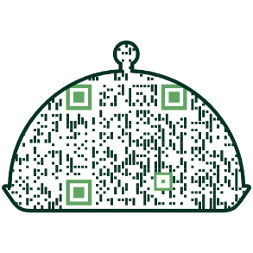](https://blogs.uoregon.edu/foodsthatconnectus/)**

5. **REFLECT** on your learning and growth. How did you interact in August? What are areas you’d like to keep learning about?

Be sure to [**complete the survey**](https://oregon.qualtrics.com/jfe/form/SV_cCMOPKwsLX8EoK2)before Aug 31 to receive your Ducks

for Diversity sticker (we’ll be

sure to get you one!)

5. **REFLEXIONA** sobre tu

aprendizaje y crecimiento.

¿Cómo han interactuado

durante agosto y cuáles son las áreas sobre las que les gustaría seguir aprendiendo?

Asegúrese de [**completar la encuesta**](https://oregon.qualtrics.com/jfe/form/SV_cCMOPKwsLX8EoK2) antes del 31 de agosto para recibir su pegatina de Patos para la Diversidad “Ducks for Diversity sticker” (¡nos aseguraremos de conseguirle una!)

2. **REGISTER by email (dsharp@uoregon.edu)** for the last Everyday Inclusion activity of this year.

**Tues, Aug 30, 1-2pm, VIRTUAL**: The Inclusive Work Environment - where we are now, where we want to be, with Deborah Butler (AVP of Campus Services) and Russ Pierson (AVP for Technical Education and Workforce Development at Lane Community College).

3. **EXPLORE** how two busy

UO alums are serving their

Indigenous communities

as elected leaders.

(scan QR code)🡪

[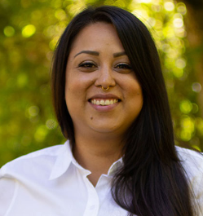](https://around.uoregon.edu/listen-learn-act-february-2022) [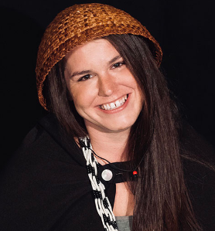](https://around.uoregon.edu/listen-learn-act-february-2022)

[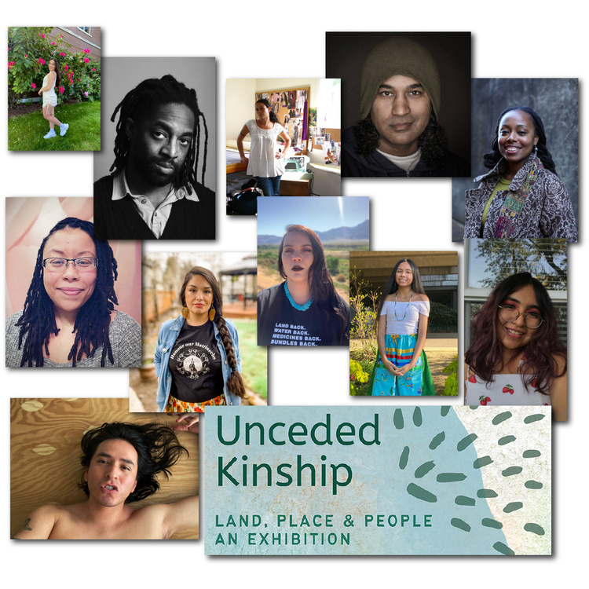](https://researchguides.uoregon.edu/unceded-kinship/)

4. **ATTEND** an in-person reception at the Knight Library to mark the end of the [**Unceded Kinship Exhibit**](https://link.pblc.app/c/541425106?alt_obj=hre&method=email&url=https%3A%2F%2Fcalendar.uoregon.edu%2Fevent%2Funceded_kinship_exhibition_reception%23.Ywz_93bMKUm&hash=3d9469&chk=306934-2371fc) on Tues, Aug 30, 3:30-5pm. No registration required. Simply show up to meet the artists, enjoy light refreshments, and view art honoring Native and Afro descendent peoples.

# **Everyday Inclusion 2022 - WEEKLY CHALLENGES (Aug 29-Sept 2)**

**1. ENJOY** the [**recipes and reflections**](https://blogs.uoregon.edu/foodsthatconnectus/) shared by colleagues across

Finance and Administration. Send your recipes **in English or Spanish**

**to** [dsharp@uoregon.edu](mailto:dsharp@uoregon.edu)this week to be included in the full recipe book**!**

**DISFRUTE** de las [**recetas y reflexiones**](https://link.pblc.app/c/541376465?alt_obj=hre&method=email&url=https%3A%2F%2Fblogs.uoregon.edu%2Ffoodsthatconnectus%2Fabout-the-foods-that-connect-us%2F&hash=8fc412&chk=306934-2371fc) compartidas por colegas de Finanzas y Administración. ¡Comparta su propia receta **en inglés o español (**[dsharp@uoregon.edu](mailto:dsharp@uoregon.edu)**)** esta semana para incluirla en el libro de recetas completo!

*[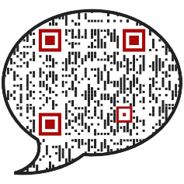](https://around.uoregon.edu/listen-learn-act-february-2022)*

[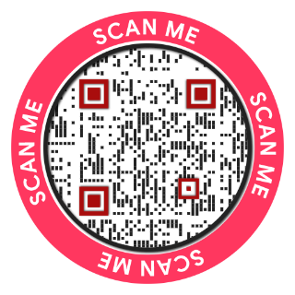](https://oregon.qualtrics.com/jfe/form/SV_cCMOPKwsLX8EoK2)

Thank you for engaging in *Everyday Inclusion 2022* throughout August.

Find out more: [https://vpfa.uoregon.edu/everyday-inclusion-2022-connection-and-belonging](https://link.pblc.app/c/538149778?alt_obj=hre&method=email&url=https%3A%2F%2Fvpfa.uoregon.edu%2Feveryday-inclusion-2022-connection-and-belonging&hash=ec69a1&chk=305640-d0548c)