Everyday Inclusion In-Person Scavenger Hunt August 2021:
(Re) Connecting to People and Place
Instructions
- This is designed as an in-person scavenger hunt to be completed on and around the UO campus. If you prefer to complete a virtual version, we have one of those, too (see the Everyday Inclusion 2021 homepage for the link: https://vpfa.uoregon.edu/everyday-inclusion-2021).

- You may complete this at any time during August 2021.

- The scavenger hunt does not have to be completed all at once but if you choose to do it that way, it should take about an hour and a half (varies by walking/rolling speed and campus familiarity).

- You may complete this by yourself or with colleagues, friends, or family. The choice is completely yours—have fun with it. Please take care and be aware of your surroundings.

- Most of the questions are designed so that you can answer them with information at the location. A few questions will require you to find the information online or elsewhere.

- Please send your completed entries to Debbie Sharp by email (dsharp@uoregon.edu), Campus Mail (to the VPFA office in 103D Johnson Hall), or via the drop boxes in various locations around campus (e.g., CPFM Admin office, Key Box in Lillis, the Grounds House, etc.).
  - If you complete all questions (correct or not) you will be entered into the portfolio-wide Everyday Inclusion drawing for a gift card or Duck Bucks.
  - The first 20 people to complete a scavenger hunt—virtual or in-person—will receive an Everyday Inclusion gift bag. Bags are limited to one per person. The bag includes assorted items generously donated by CPFM Zero Waste and Utilities and Energy, UOPD, Print Services, Safety and Risk Services, and a range of departments on and around campus that are outside our portfolio but wanted to support our inclusion efforts (EMU, Orientation Programs, Museum of Natural and Cultural History, Jordan Schnitzer Museum of Art, and University Health Services).

- Happy hunting!
Name: ____________________ Date completed (we trust you): ____________________
Email address: ____________________

Everyday Inclusion On-Campus Scavenger Hunt August 2021:
(Re) Connecting to People and Place
HINTS: Each question signals a new location on campus (unless stated otherwise). Also, to help orient yourself to campus, you may want to have the UO Map handy (https://map.uoregon.edu/).

- In November 2014, flags were raised to honor the state’s nine tribal nations. We begin our scavenger hunt at the location of these flags and with a land acknowledgement:

The University of Oregon is located on Kalapuya Ilihi, the traditional indigenous homeland of the Kalapuya people. Following treaties between 1851 and 1855, Kalapuya people were dispossessed of their indigenous homeland by the United States government and forcibly removed to the Coast Reservation in Western Oregon. Today, descendants are citizens of the Confederated Tribes of Grand Ronde Community of Oregon and the Confederated Tribes of the Siletz Indians of Oregon, and continue to make important contributions in their communities, at UO, across the land we now refer to as Oregon, and around the world.

Now for the question: What is the background color of the flag of the Confederated Tribes of the Warm Springs Reservation of Oregon?

- Stay in question #1’s location and look around you. There are several small brass signs around the base of your location. How many are there and what does your favorite sign say?

- To the east—not far from the location of #2 and home to the physics department—this building features a gargoyle sculpture of a famous woman. Who is it and what is she famously known for?
Hints: She’s up high and kind of hidden behind a big tree; think radioactivity…

BONUS: Do you recognize any of the other gargoyles on the exterior of the building?

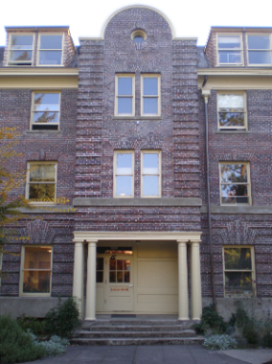
- Move west past the Volcanology building and turn right. Tucked between four science buildings lies a waterfall fountain designed by Alice Wingwall to engage senses other than sight because at the time of its design she was going blind. What is the name of the waterfall? (unfortunately, the site has no water at the moment).

- A short walk to the west from #4 is a building that was the first co-ed
dormitory in the US. What is the name of the building?
- North west of the site of question 5 sits the university's oldest building which, in June 2020, was renamed by the UO Board of Trustees due to the racist views held by the building’s former namesake. What is the building’s current (temporary) name?

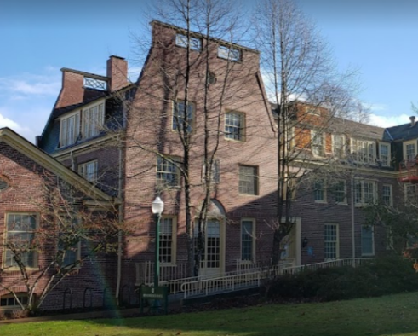
- Move south to this hall that is nestled between Johnson and Chapman Halls. Inside is a central rain-like art installation featuring 1,100 elements. It’s really worth seeing if you are there on a weekday between 8 and 5. At the entrance to the building is a quote by W.E.B. Du Bois. What does it say?

- Moving south east and across the quad from #7’s location is a building that is currently home to the Center for Latino/a Studies, the Center for the Study of Women in Society, and the department of Women, Gender and Sexuality Studies. What is the name of this building?

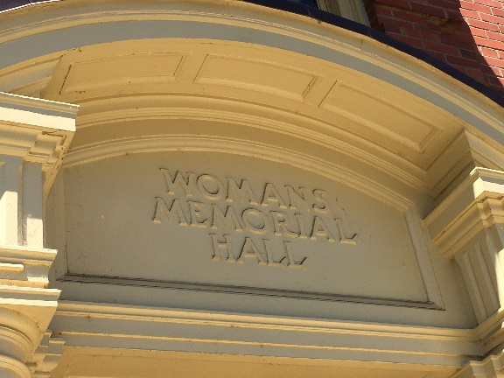

- Continue moving south to a building named for the first woman regent of the UO and which—along with Susan Campbell Hall and the building in #8—frames the Women’s Memorial Quadrangle. It used to be known as the Woman’s Memorial Hall. What is this building now named?

- Next, cross the street to your east and explore the outdoor artwork there. You will find a striking sculpture by American artist and UO graduate, Ellen Tykeson. According to the artist, the statue is an archetypal female figure that “juxtaposes the beauty of the mysterious with the acceptance of the burdens inherent in life.” What is the name of the sculpture?

** This is a good point for a break and refreshments at the EMU if needed. **

- Move east along 15th past the Student Recreation Center and an athletic turf field to a structure that rises high above campus and prominently features a woman who won four of her six NCAA titles in Eugene. What is the structure?
BONUS: Who is the accomplished alum?

- A short walk to the southeast from the previous question’s location, you will find an interesting building with a green roof composed of more than 20 indigenous Oregon grasses and other native perennials. What is the name of this building?

- Between the previous question’s location and the Kalapuya Ilihi residence hall is a sculpture by an artist and member of the Wiyot Mad River Band. What is his name?
BONUS: What is your impression of the piece?
- Just inside the glass entrance doors to the Kalapuya Ilihi residence hall is the following statement. Fill in the blanks.
“We share this living space with __________________ and ________________ for the Kalapuya homeland and for the indigenous peoples who continue to live and thrive in what is now called the State of Oregon.”

- Your next stop is close. It is a place where you are likely to find some of the youngest members of the UO community. Hint: One-story gray building to the west.
To the left of the entrance is an artwork encouraging us to be _________________. [Fill in the blank]

- A short walk to the north of the previous question’s building is a place where you will find five copper sculptures of animals. Each represents an important character trait among Pacific Northwest Indigenous cultures. What are the five animals and their traits?
BONUS: Which of these animals resonates with you and why?

- Move west to Agate Street and pause to admire UO’s newest residence hall in its final stages of construction. Set to open in fall 2021, the hall honors the first African American to graduate from the UO’s School of Architecture and Allied Arts (now known as the College of Design). How many floors does this building have?
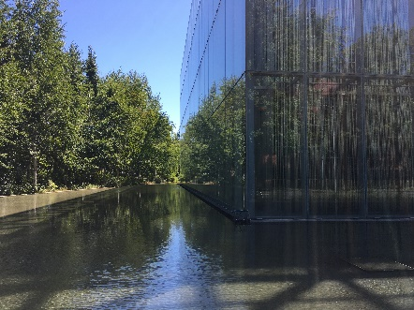
BONUS: What is the name of the hall?

- Move toward Franklin Boulevard to this distinctive building. Get close and take a peek. Unlike most buildings, this one has two facades, with a five-foot gap between them. This isn’t just for looks. What do you think is the purpose of this?

BONUS: Look right while facing the front doors. What is interesting about the bike racks you see?

- Move west across the street to the building that is home to the Center for Multicultural Academic Excellence, this building has words in various languages on its entrance doors. What do the words mean?

- Move back to where you started. Inside this facility is the Mills International Center, the Women’s Center, and the offices of a number of student clubs and groups aimed at helping students to feel connected to the UO. Name two more student-focused groups, programs, or services with a visible presence in this building.
BONUS: What makes you feel connected to the UO?

OPTIONAL EXTRAS:
- Highlight something new you learned through this scavenger hunt.

- Please share any impressions you might have of this activity.

